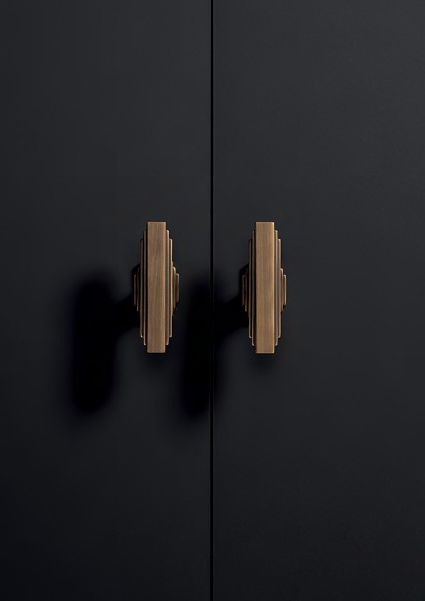

Product Guide

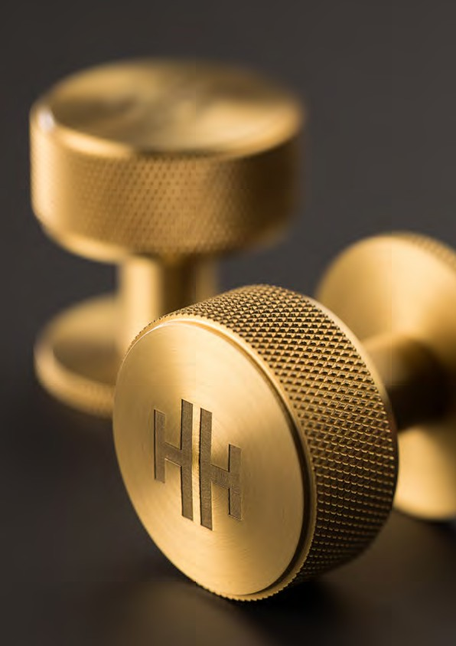
Belgravia

British Design, Global Inspiration.
Bringing furniture to life is our mission.

Our handles are manufactured to be as tactile as they are aesthetic. Our collections are designed to be as unique as they are practical.

As a team of designers and engineers, we don’t wait for trends. We create them. Leaning on our British Heritage, we find inspirations from around the globe and bring it home to forge the finest handles.

Throughout this product guide, you will explore our featured collections, curated by our dedicated team of designers.

No matter the furniture, we’ll handle it.

2 3

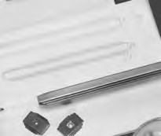
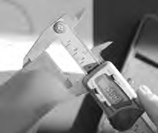
1 4
Design Concepts & Inspiration Tooling

Our Dedication to Perfection
2
5

Every handle we make has to earn its place – in our
range and on your project. Nothing leaves our factory until it’s the perfect balance of form and function. Getting
there isn’t simple and we have a 6 step approach. It takes a team of artists and engineers to create the concept,
an expert eye to source the highest quality materials, and craftsmen to bring it to life.
In-House 3D Visualisation & Printing Manufacturing & Finishing
The result is a handle that has been refined to perfection, one we’re proud to put our name on.
3 6
Material & Finish Selection Quality Assurance & Testing

4 5

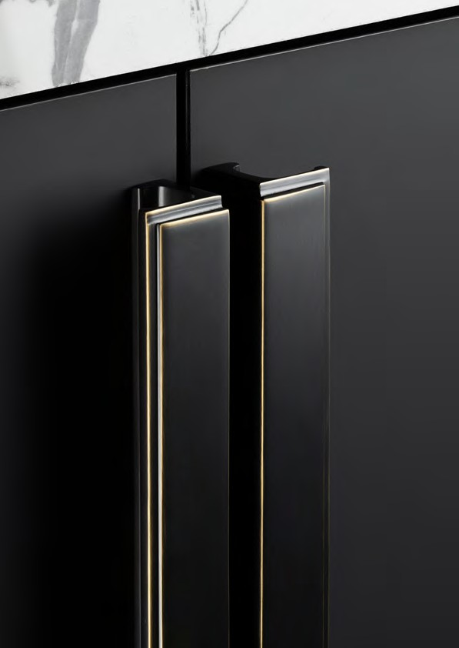
Felix

 | Collections
 | Transitional |  | Contemporary
 | Fitzrovia | 10-15 | Battersea | 94-97
 | Ark | 16-19 | Jura | 98-99
 | Belgravia | 20-21 | Reba | 100-101
 | Barrington | 22-27 | Edison | 102-103
 | Barrington Eclipse | 28-31 | Lincoln | 104-105
 | Felix | 32-35 | Kellas | 106-109
 | Geddes | 36-39 | Milano | 110-111
 | Pembrey | 40-43 | Aubyn | 112-113
 | Ambrose | Cosmo | 44-45 | Campana | 114-115
 | Liberty | 46-51 | Lago | 116-117
 | Hudson | 52-55 | Coleby | 118-119
 | Otto | 56-57
 | Lumi | 58-59
 | Newport | 60-61 | Statement Knobs
 | Casper | 62-63 | Hugo | 120
 |  |  | Ilsa | 121
 | Traditional |  | Chelsea | 122
 | Greenwich | 66-67 | Ivo | 123
 | York | 68-69 | Evora | 124
 | Callcott | 70-75 | Kew | 125
 | Hampton | 76-79
 | Jago | 80-81
 | Trafalgar | 82-83
 | Finsbury | 84-85
 | Fleur | 86-87
 | Charlbury | Coco | 88-89
 | Hebe | 90-91
6 |  |  |  |  | 7

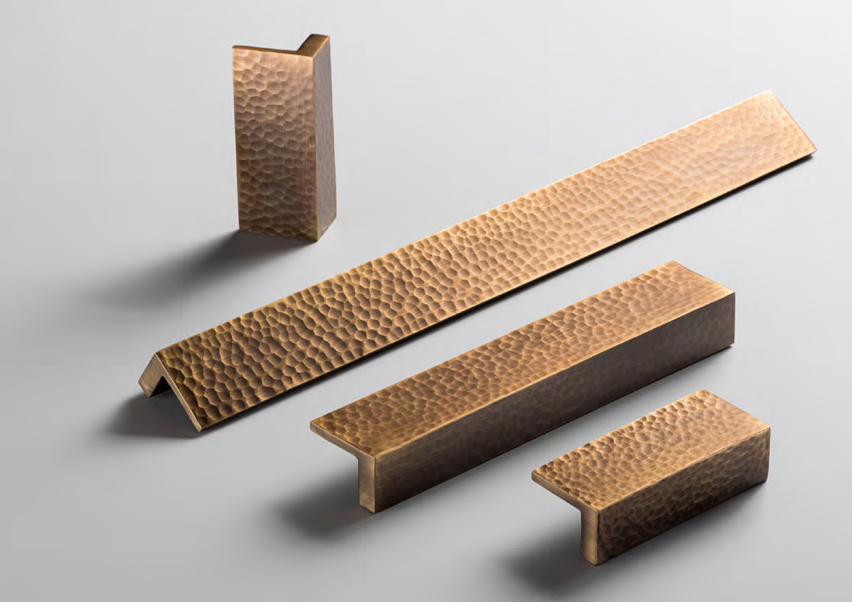

Transitional

8 9

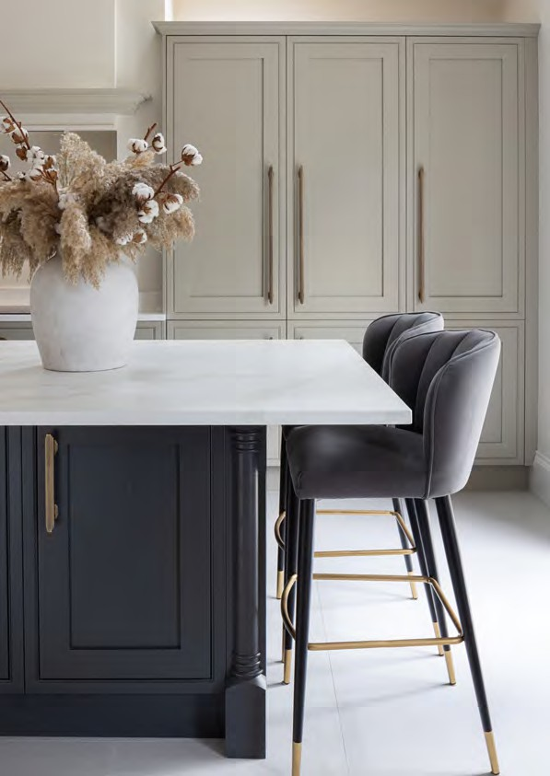

Fitzrovia Collection

Influenced by Art Deco design, Fitzrovia is characterized
by distinct stepped detailing and the perfect art of symmetry.
Each of the five pieces include matching backplates, creating a striking silhouette when set in context. Luxury, sophistication,
and functionality come together perfectly to form this statement collection that will elevate any space.

10 11

3 4 MM KNOB WITH B A CKPL ATE

C ODE : GFITK 0 3 4
FINISH CODE
BB, BN, BSB, DBB, MBL, PN
Fitzrovia

PROJECTION
34MM
KNOB DIAMETER
34MM
BACKPLATE THICKNESS
5MM

8 2 MM T - B AR KNOB WITH B A CKPL ATE

C ODE : GFITK 0 8 2
FINISH CODE
BB, BN, BSB, DBB, MBL, PN

PROJECTION
34MM
OVERALL LENGTH
82MM
WIDTH X HEIGHT
20MM X 10MM
BACKPLATE THICKNESS
5MM

160MM PULL HANDLE WITH BACKPLATES

C ODE : GFITP 1 6 0
FINISH CODE
BB, BN, BSB, DBB, MBL, PN

Fitzrovia Collection

HOLE CENTRES PROJECTION OVERALL LENGTH WIDTH X HEIGHT BACKPLATE THICKNESS

160MM
34MM
240MM
20MM X 10MM
5MM

Influenced by Art Deco design, Fitzrovia is characterized by distinct stepped detailing and the perfect art of symmetry.
Each of the five pieces include matching backplates, creating a striking silhouette when set in context. Luxury, sophistication, and functionality come together perfectly to form this statement collection that will elevate any space.
Made from Brass. Includes fixings.

FINISHES

320MM PULL HANDLE WITH BACKPLATES

C ODE : GFITP 3 2 0
FINISH CODE
BB, BN, BSB, DBB, MBL, PN

BURNISHED

BRUSHED

BRUSHED SATIN

DARK BRUSHED

MATT BLACK

POLISHED
HOLE CENTRES PROJECTION OVERALL LENGTH WIDTH X HEIGHT BACKPLATE THICKNESS

BRASS (BB)
NICKEL (BN)
BRASS (BSB)
BRASS (DBB)
(MBL)
NICKEL (PN)
320MM
34MM
400MM
20MM X 10MM
5MM

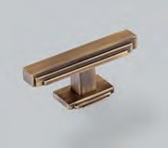
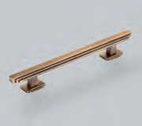
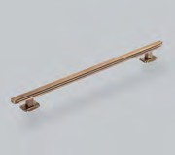
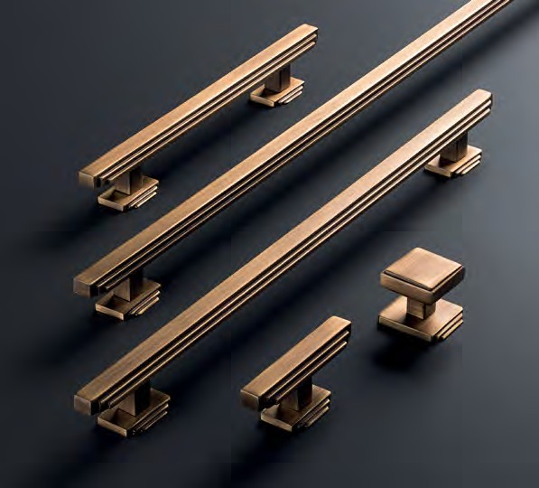
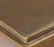
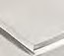
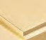
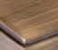
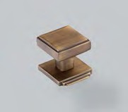
12 13

Fitzrovia

608MM PULL HANDLE WITH BACKPLATES

C ODE : GFITP 6 0 8
FINISH CODE
BB, BN, BSB, DBB, MBL, PN

HOLE CENTRES PROJECTION OVERALL LENGTH WIDTH X HEIGHT BACKPLATE THICKNESS

608MM
34MM
688MM
20MM X 10MM
5MM

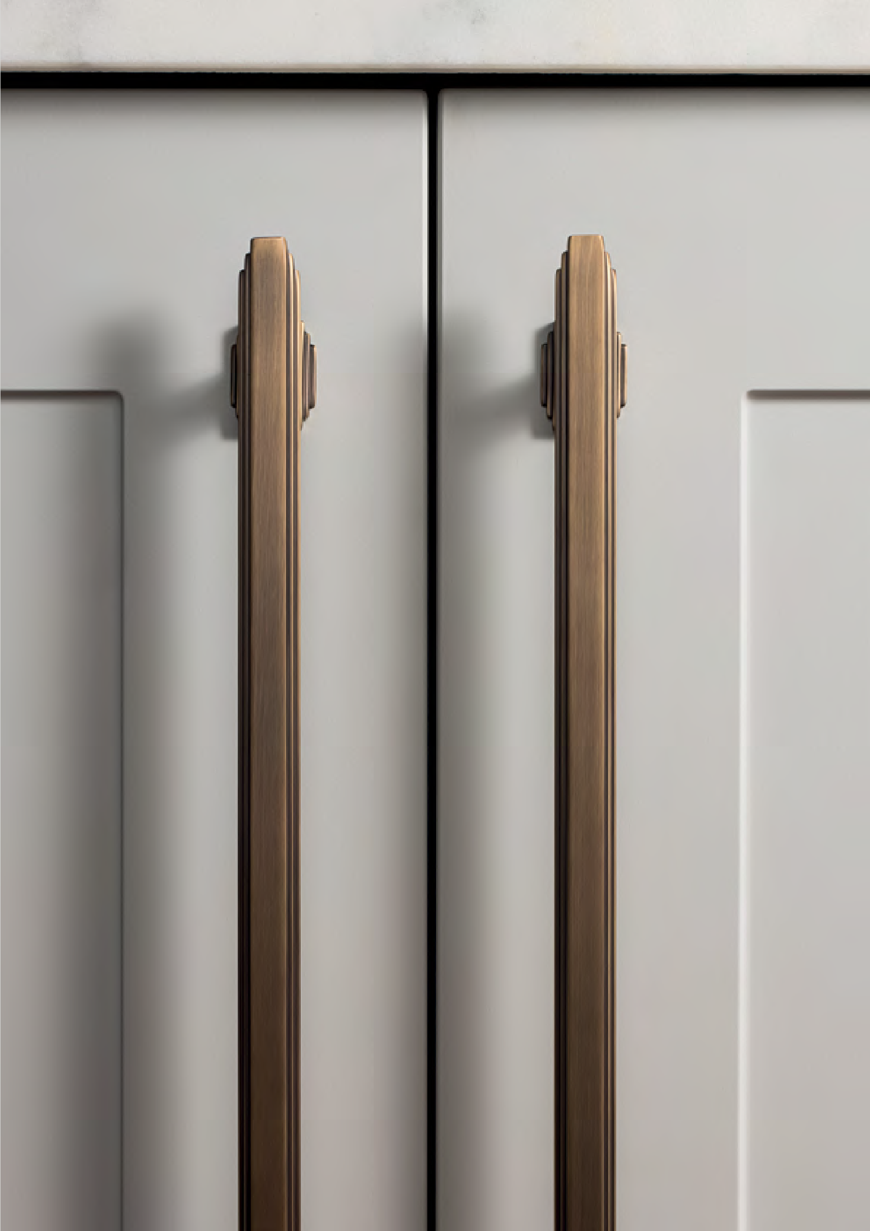
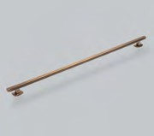

Luxury, sophistication, and
functionality come together perfectly to form this statement collection that will elevate any space.

14 15

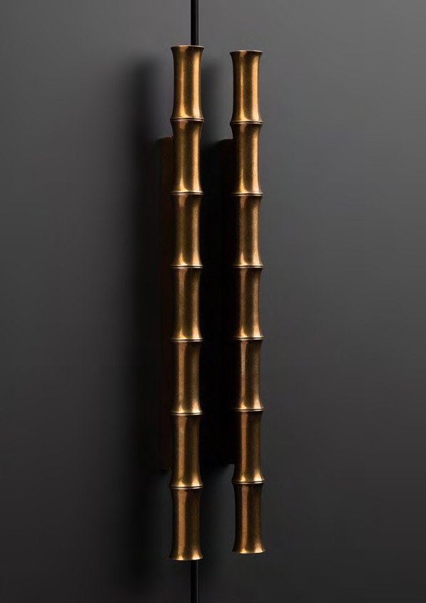

Ark Collection

Capturing the clean, continuous form of bamboo, Ark brings nature to the interior with subtle ridges emulating the
nodes of natural bamboo and thoughtfully proportioned segments providing perfect tactility.

16 17

3 2 MM PULL HANDLE

C ODE : G ARP 0 3 2
FINISH CODE
BB, BSB, ORB, PN
Ark

HOLE CENTRES
32MM
PROJECTION
30MM
OVERALL LENGTH
114MM
BAR THICKNESS
18MM

1 6 0 MM PULL HANDLE

C ODE : G A R P 160
FINISH CODE
BB, BSB, ORB, PN

HOLE CENTRES
160MM
PROJECTION
30MM
OVERALL LENGTH
266MM
BAR THICKNESS
18MM

3 2 0 MM PULL HANDLE

C ODE : G A R P 320
FINISH CODE
BB, BSB, ORB, PN

Ark Collection

HOLE CENTRES PROJECTION OVERALL LENGTH BAR THICKNESS

320MM
33MM
418MM
20MM

Capturing the clean, continuous form of bamboo, Ark brings nature to the interior with subtle ridges emulating the nodes of natural bamboo and thoughtfully proportioned segments providing perfect tactility.
Made from Brass. Includes fixings.

FINISHES

BURNISHED BRASS (BB)
BRUSHED SATIN BRASS (BSB)
OIL RUBBED BRONZE (ORB)
POLISHED NICKEL (PN)

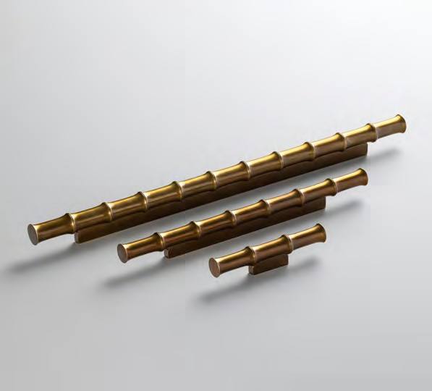
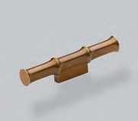
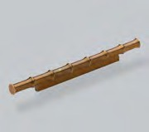
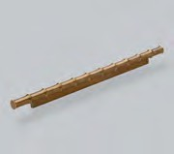
18 19

3 5 MM KNOB

C ODE : GBELK 0 3 5
FINISH CODE
BN, DBB, MBL, PN, SBL
Belgravia

PROJECTION
38MM
KNOB DIAMETER
35MM

8 2 MM T - B AR KNOB

C ODE : GBELK 0 8 2
FINISH CODE
BN, DBB, MBL, PN, SBL

PROJECTION
24MM
OVERALL LENGTH
82MM
BAR THICKNESS
14MM

1 6 0 MM PULL HANDLE

C ODE : GBELP 1 6 0
FINISH CODE
BN, DBB, MBL, PN, SBL

Belgravia Collection

HOLE CENTRES
160MM

PROJECTION
38MM

OVERALL LENGTH
242MM

BAR THICKNESS
14MM

Each angle of Belgravia has been considered to form the perfect balance of texture. Crafted to exacting standards, the intricate knurling wraps
around each of the four pieces to create a cohesive collection.
Made from Brass. Includes fixings.

FINISHES

3 2 0 MM PULL HANDLE

C ODE : GBELP 3 2 0
FINISH CODE
BN, DBB, MBL, PN, SBL

BRUSHED NICKEL (BN)

DARK BRUSHED BRASS (DBB)

MATT BLACK
(MBL)

POLISHED NICKEL (PN)

SATIN BRASS LACQUERED (SBL)
HOLE CENTRES
320MM
PROJECTION
38MM
OVERALL LENGTH
402MM
BAR THICKNESS
14MM

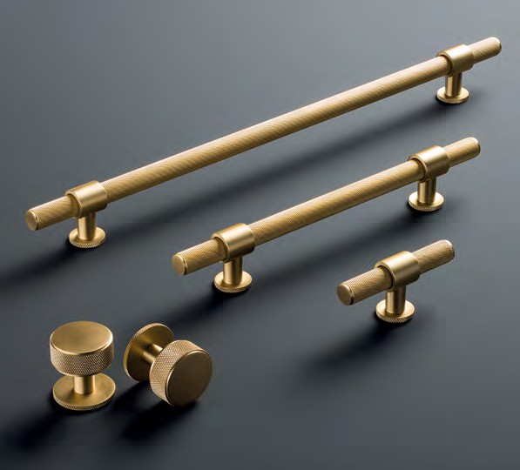
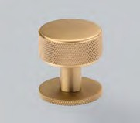
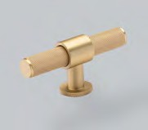
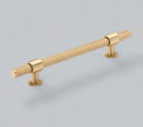
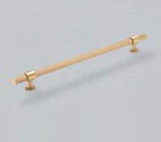
20 21

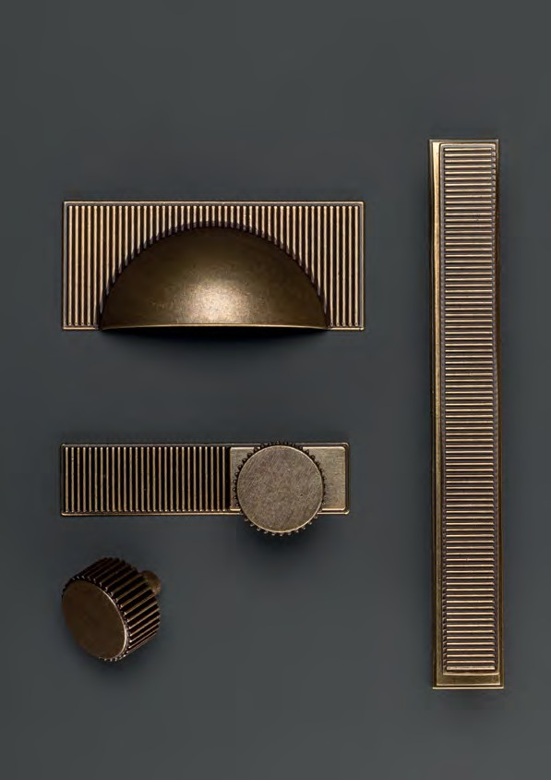

Barrington Collection

This signature collection features a striking ribbed texture, taking elements of inspiration from Art Deco design. With its bold industrial flair and fine details, the Barrington collection makes a statement.

22 23

3 2 MM KNOB

C ODE : GB AK 0 3 2
FINISH CODE
BRO, BSB, DBB, DN, MBL, PN
Barrington

PROJECTION
29MM
KNOB DIAMETER
32MM

1 0 0 MM B A CKPL ATE F OR KNOB

C ODE : GB ABP 1 0 0
FINISH CODE
BRO, BSB, DBB, DN, MBL, PN

OVERALL LENGTH
100MM
HEIGHT
25MM
BACKPLATE THICKNESS
4MM

1 6 0 MM PULL HANDLE

C ODE : G B A P 160
FINISH CODE
BRO, BSB, DBB, DN, MBL, PN

Barrington Collection

HOLE CENTRES
160MM

PROJECTION
30MM

OVERALL LENGTH
180MM

BAR THICKNESS
20 X 10MM

This signature collection features a striking ribbed texture, taking
elements of inspiration from Art Deco design. With its bold industrial flair and fine details, the Barrington collection makes a statement.
Made from Zamac. Includes fixings.

FINISHES

1 6 0 MM B A CKPL ATE F OR PULL HANDLE

C ODE : G U 0 1B P1 6 0
FINISH CODE
BRO, BSB, DBB, DN, MBL, PN

BRONZE
(BRO)

BRUSHED SATIN BRASS (BSB)

DARK BRUSHED BRASS (DBB)

DULL NICKEL
(DN)

MATT BLACK
(MBL)

POLISHED NICKEL (PN)
HOLE CENTRES
160MM
OVERALL LENGTH
190MM
DEPTH
25MM
BACKPLATE THICKNESS
4MM

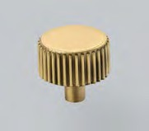
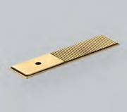
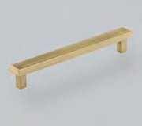
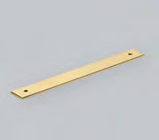
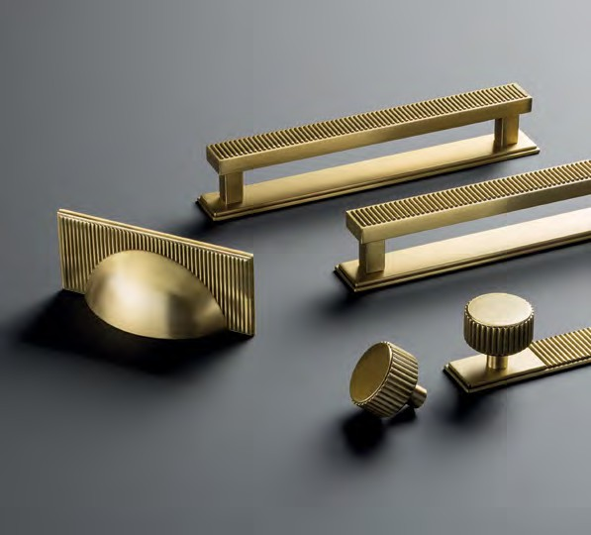
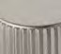
24 25

3 2 0 MM PULL HANDLE

C ODE : G B A P 320
FINISH CODE
BRO, BSB, DBB, DN, MBL, PN
Barrington

HOLE CENTRES
320MM
PROJECTION
35MM
OVERALL LENGTH
340MM
BAR THICKNESS
20 X 11MM

3 2 0 MM B A CKPL ATE F OR PULL HANDLE

C ODE : G U 0 2 B P3 2 0
FINISH CODE
BRO, BSB, DBB, DN, MBL, PN

HOLE CENTRES
320MM
OVERALL LENGTH
350MM
DEPTH
25MM
BACKPLATE THICKNESS
4MM

6 4 MM CUP HANDLE

C ODE : G B AC 0 6 4
FINISH CODE
BRO, BSB, DBB, DN, MBL, PN

HOLE CENTRES
64MM
PROJECTION
24MM
OVERALL LENGTH
105MM
HEIGHT
45MM

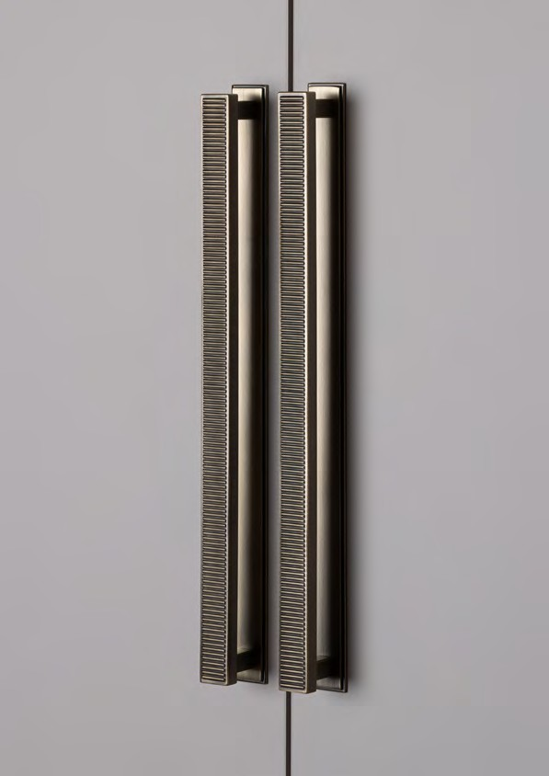
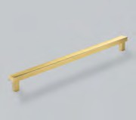
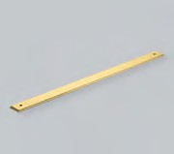
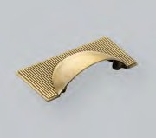

26 27

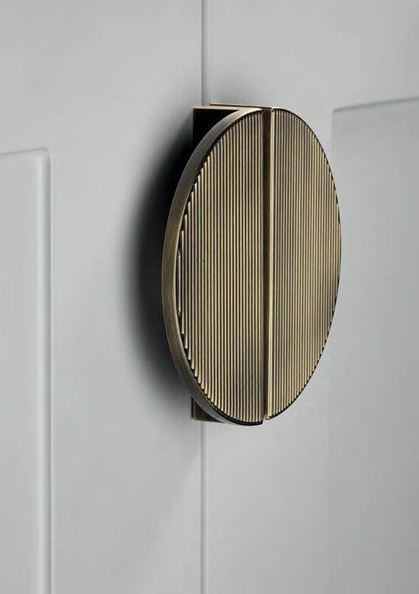

Barrington Eclipse Collection

A statement pull designed as part of the
Barrington collection. The Eclipse can be used as a stand-alone, half-moon shape or,
when fitted side by side, a full moon.
Mix and match the smooth and ribbed texture to create your own statement.

28 29

6 4 MM RIBBED PULL HANDLE

C ODE : GBETP 0 6 4
FINISH CODE
BRO, BSB, DBB, DN, MBL, PN
Barrington Eclipse

HOLE CENTRES
64MM
PROJECTION
26MM
OVERALL LENGTH
80MM
HEIGHT
40MM

6 4 MM SMOO TH PULL HANDLE

C ODE : GBEPP 0 6 4
FINISH CODE
BRO, BSB, DBB, DN, MBL, PN

HOLE CENTRES
64MM
PROJECTION
26MM
OVERALL LENGTH
80MM
HEIGHT
40MM

9 6 MM RIBBED PULL HANDLE

C ODE : GBETP 0 9 6
FINISH CODE
BRO, BSB, DBB, DN, MBL, PN

Barrington Eclipse Collection

HOLE CENTRES
96MM

PROJECTION
26MM

OVERALL LENGTH
112MM

HEIGHT
56MM

A statement pull designed as part of the Barrington collection.
The Eclipse can be used as a stand-alone, half-moon shape or, when fitted side by side, a full moon. Mix and match the smooth and ribbed texture to create your own statement.
Made from Zamac. Includes fixings.

FINISHES

9 6 MM SMOO TH PULL HANDLE

C ODE : GBEPP 0 9 6
FINISH CODE
BRO, BSB, DBB, DN, MBL, PN

BRONZE
(BRO)

BRUSHED SATIN BRASS (BSB)

DARK BRUSHED BRASS (DBB)

DULL NICKEL
(DN)

MATT BLACK
(MBL)

POLISHED NICKEL (PN)
HOLE CENTRES
96MM
PROJECTION
26MM
OVERALL LENGTH
112MM
HEIGHT
56MM

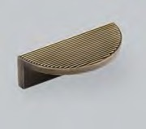
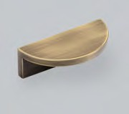
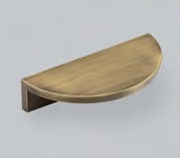
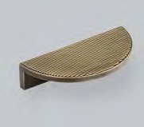
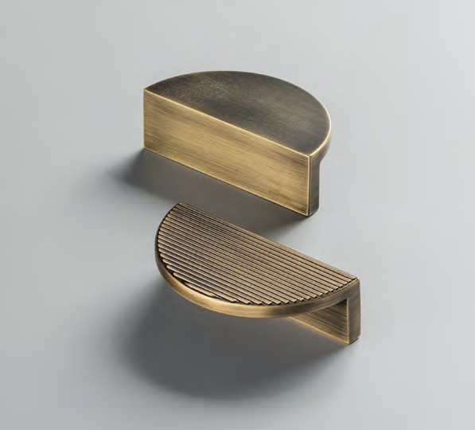
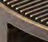
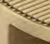
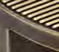
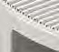
30 31

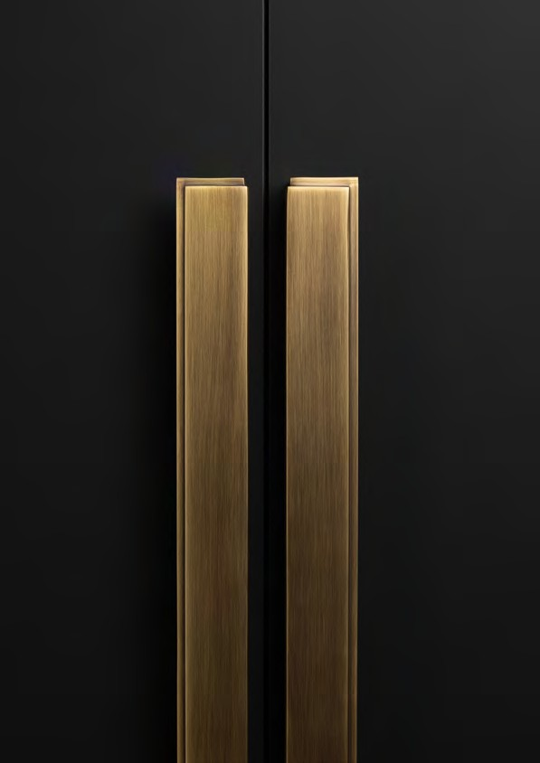

Felix Collection

Combining a captivating stepping detail with an ergonomic profile shape, Felix is a discreet hardware choice for any interior space.
Inspired by the upright, parallel aesthetic of a city skyline, the design proportions blend form with function to create a
sophisticated and refined collection.

32 33

6 4 MM PULL HANDLE

C ODE : GFEP 0 6 4
FINISH CODE
BB, BSB, DBB, MBL, ORB, PN
Felix

HOLE CENTRES
64MM
PROJECTION
28MM
OVERALL LENGTH
74MM
HEIGHT
30MM

1 9 2 MM PULL HANDLE

C ODE : GFEP 1 9 2
FINISH CODE
BB, BSB, DBB, MBL, ORB, PN

HOLE CENTRES
192MM
PROJECTION
28MM
OVERALL LENGTH
202MM
HEIGHT
30MM

4 4 8 MM PULL HANDLE

C ODE : GFEP 4 4 8
FINISH CODE
BB, BSB, DBB, MBL, ORB, PN

Felix Collection

HOLE CENTRES PROJECTION OVERALL LENGTH HEIGHT

448MM
224MM X 2
458MM
36MM

Combining a captivating stepping detail with an ergonomic profile shape, Felix is a discreet
hardware choice for any interior space. Inspired by the upright, parallel aesthetic of a city skyline, the design proportions blend form with function to create a sophisticated and refined collection.
Made from Brass. Includes fixings.

FINISHES

BURNISHED BRASS (BB)
BRUSHED SATIN BRASS (BSB)
DARK BRUSHED BRASS (DBB)
MATT BLACK
(MBL)
OIL RUBBED BRONZE (ORB)
POLISHED NICKEL (PN)

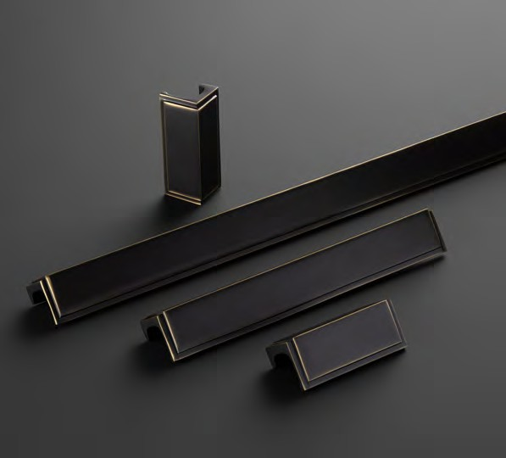
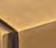
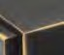
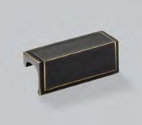
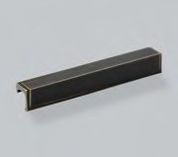
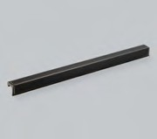
34 35

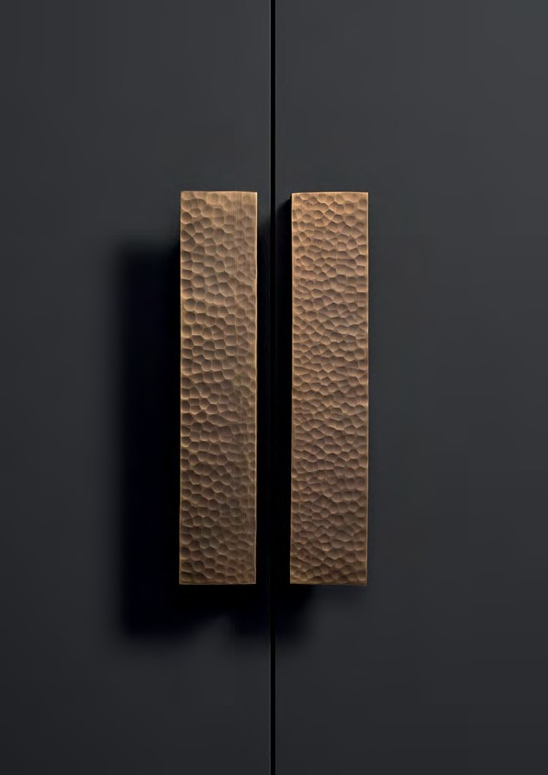

Geddes Collection

Hand crafted and individually hammered, the organic texture of this collection creates stunning highlights and shadows to bring any piece of furniture to life.
Designed to work seamlessly with both traditional and contemporary spaces, with each piece being unique,
this collection promises to make a statement.

36 37

6 4 MM PULL HANDLE

C ODE : GGEP 0 6 4
FINISH CODE
DBB, PN, SBL
Geddes

HOLE CENTRES
64MM
PROJECTION
23MM
OVERALL LENGTH
84MM
HEIGHT
35MM

1 6 0 MM PULL HANDLE

C ODE : GGEP 1 6 0
FINISH CODE
DBB, PN, SBL

HOLE CENTRES
160MM
PROJECTION
23MM
OVERALL LENGTH
180MM
HEIGHT
35MM

3 2 0 MM PULL HANDLE

C ODE : GGEP 3 2 0
FINISH CODE
DBB, PN, SBL

Geddes Collection

HOLE CENTRES PROJECTION OVERALL LENGTH HEIGHT

160MM X 2
23MM
340MM
35MM

Hand crafted and individually hammered, the organic texture of this collection creates stunning highlights and shadows to bring any piece of furniture to life. Designed to work seamlessly with both traditional and contemporary spaces, with each piece being unique, this collection promises to make a statement.
Made from Brass. Includes fixings.

FINISHES

DARK BRUSHED BRASS (DBB)
POLISHED NICKEL (PN)
SATIN BRASS LACQUERED (SBL)

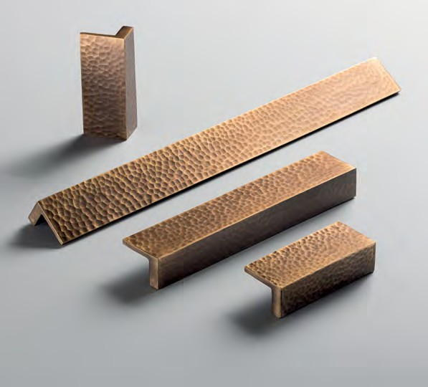
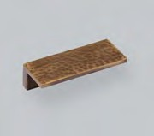
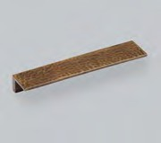
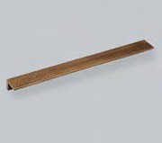
38 39

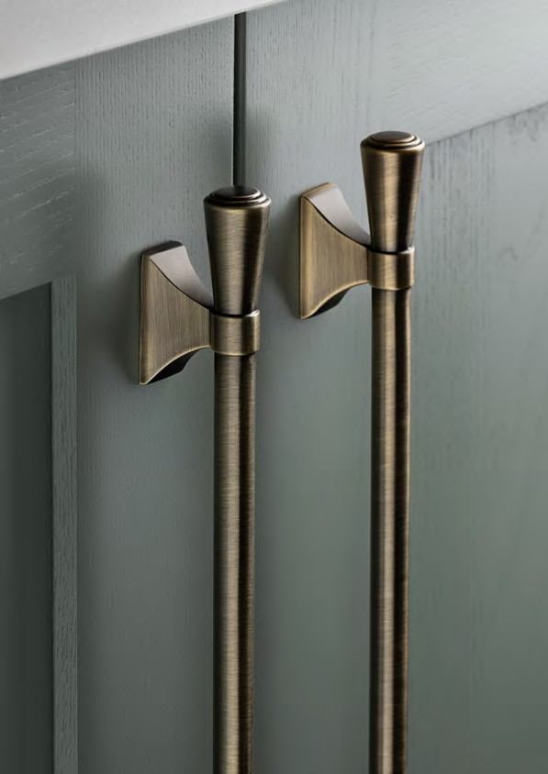

Pembrey Collection

This timeless collection features concentric detailing and a flared foot design perfectly suited to both slab
and shaker cabinetry.

40 41

8 2 MM T - B AR KNOB

C ODE : GPEK 0 8 2
FINISH CODE
BRO, BSB, DBB, MBL, PN
Pembrey

PROJECTION
37MM
OVERALL LENGTH
82MM
BAR THICKNESS
19MM

1 2 8 MM B AR HANDLE

C ODE : GPEB 1 2 8
FINISH CODE
BRO, BSB, DBB, MBL, PN

HOLE CENTRES
128MM
PROJECTION
37MM
OVERALL LENGTH
210MM
BAR THICKNESS
12MM

3 2 0 MM B AR HANDLE

C ODE : GPEB 3 2 0
FINISH CODE
BRO, BSB, DBB, MBL, PN

Pembrey Collection

HOLE CENTRES PROJECTION OVERALL LENGTH BAR THICKNESS

320MM
37MM
402MM
12MM

This timeless collection features concentric detailing and a flared foot design perfectly suited to both slab and shaker cabinetry.
Made from Zamac. Includes fixings.

FINISHES

BRONZE
(BRO)
BRUSHED SATIN BRASS (BSB)
DARK BRUSHED BRASS (DBB)
MATT BLACK
(MBL)
POLISHED NICKEL (PN)

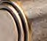
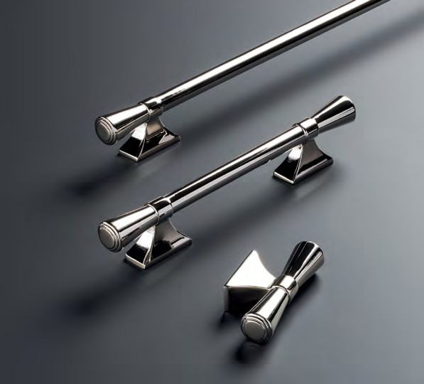
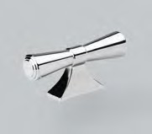
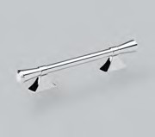
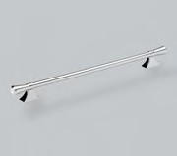
42 43

6 0 MM T - B AR KNOB

C ODE : G AMK 0 6 0 ABM
FINISH CODE
ABM
Ambrose

PROJECTION
35MM
OVERALL LENGTH
60MM
BAR THICKNESS
12MM

1 6 0 MM B AR HANDLE

C ODE : G AMB 1 6 0 ABM
FINISH CODE
ABM

HOLE CENTRES
160MM
PROJECTION
35MM
OVERALL LENGTH
195MM
BAR THICKNESS
12MM

2 2 4 MM B AR HANDLE

C ODE : G AMB 2 2 4 ABM
FINISH CODE
ABM

Ambrose Collection

HOLE CENTRES
224MM

PROJECTION
35MM

OVERALL LENGTH
260MM

BAR THICKNESS
12MM

Inspired by the contemporary bar and clasp design, the juxtaposition of the circular bar with accentuated grooves and rectangular posts, makes this an attractive all-round statement collection.
Made from Aluminium. Fixings sold separately.

FINISHES

C OSMO 3 2 MM KNOB

C ODE : GC OK 0 3 2 ABM
FINISH CODE
ABM
Cosmo

ANTIQUE BRONZE MATT (ABM)
PROJECTION
30MM
KNOB DIAMETER
32MM

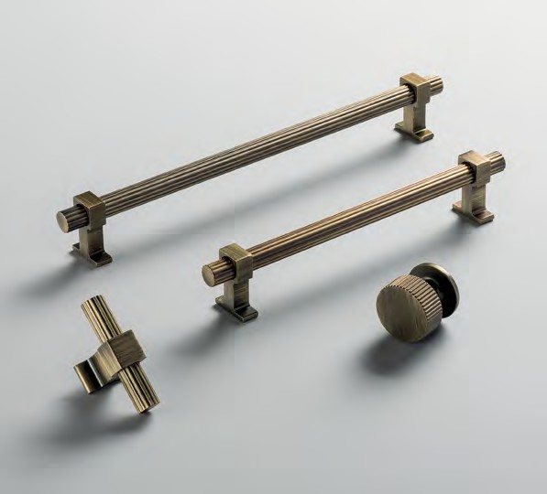
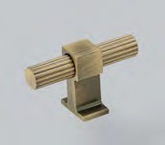
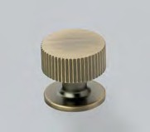
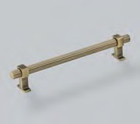
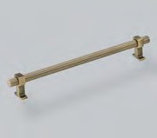
44 45

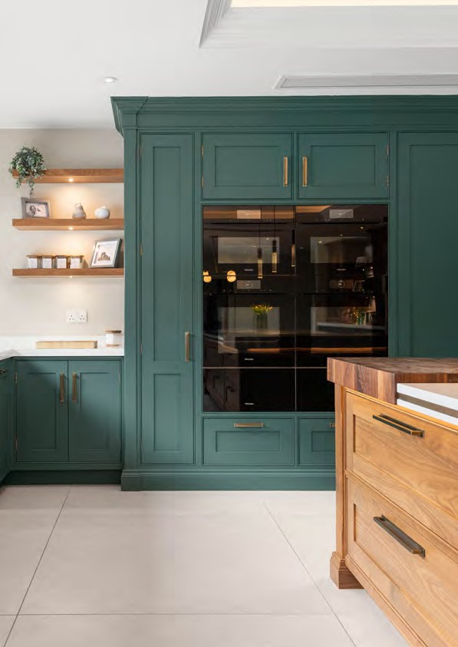

Liberty Collection

Minimalist, clean form, silhouetted by stepped backplates. Each piece of the collection
proves less is more.

46 Image Courtesy of Richard Sutton Design 47

3 4 MM KNOB

C ODE : GLIBK 0 3 4
FINISH CODE
BSB, DBB, DN, MBL, PN
Liberty

HOLE CENTRES
160MM
PROJECTION
29MM
OVERALL LENGTH
172MM
WIDTH X HEIGHT
12MM X 12MM

7 2 MM T - B AR KNOB

C ODE : GLIBK 0 7 2
FINISH CODE
BSB, DBB, DN, MBL, PN

HOLE CENTRES
320MM
PROJECTION
29MM
OVERALL LENGTH
332MM
WIDTH X HEIGHT
12MM X 12MM

1 6 0 MM PULL HANDLE

C ODE : GLIBD 1 6 0
FINISH CODE
BSB, DBB, DN, MBL, PN

Liberty Collection

HOLE CENTRES
160MM

OVERALL LENGTH
350MM

HEIGHT
25MM

BACKPLATE THICKNESS
4MM

Minimalist, clean form, silhouetted by stepped backplates.
Each piece of the collection proves less is more.
Made from Zamac. Includes fixings.

FINISHES

3 2 0 MM PULL HANDLE

C ODE : GLIBD 3 2 0
FINISH CODE
BSB, DBB, DN, MBL, PN

BRUSHED SATIN BRASS (BSB)

DARK BRUSHED BRASS (DBB)

DULL NICKEL
(DN)

MATT BLACK
(MBL)

POLISHED NICKEL (PN)
HOLE CENTRES
320MM
PROJECTION
29MM
OVERALL LENGTH
332MM
WIDTH X HEIGHT
12MM X 12MM

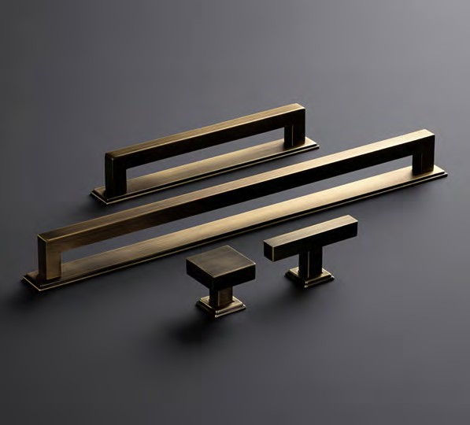
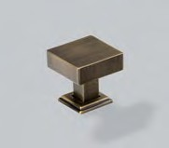
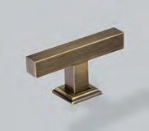
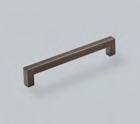
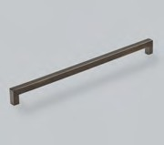
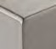
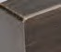
48 49

2 5 MM B A CKPL ATE PAIR F OR PULL HANDLE

C ODE : GLIBBP 0 2 5
FINISH CODE
BSB, DBB, DN, MBL, PN
Liberty

HOLE CENTRES
160MM
PROJECTION
29MM
OVERALL LENGTH
172MM
WIDTH X HEIGHT
12MM X 12MM

1 6 0 MM B A CKPL ATE F OR PULL HANDLE

C ODE : G U 0 1B P1 6 0
FINISH CODE
BSB, DBB, DN, MBL, PN

HOLE CENTRES
160MM
OVERALL LENGTH
350MM
HEIGHT
25MM
BACKPLATE THICKNESS
4MM

3 2 0 MM B A CKPL ATE F OR PULL HANDLE

C ODE : G U 0 2 B P3 2 0
FINISH CODE
BSB, DBB, DN, MBL, PN

HOLE CENTRES
320MM
OVERALL LENGTH
350MM
HEIGHT
25MM
BACKPLATE THICKNESS
4MM

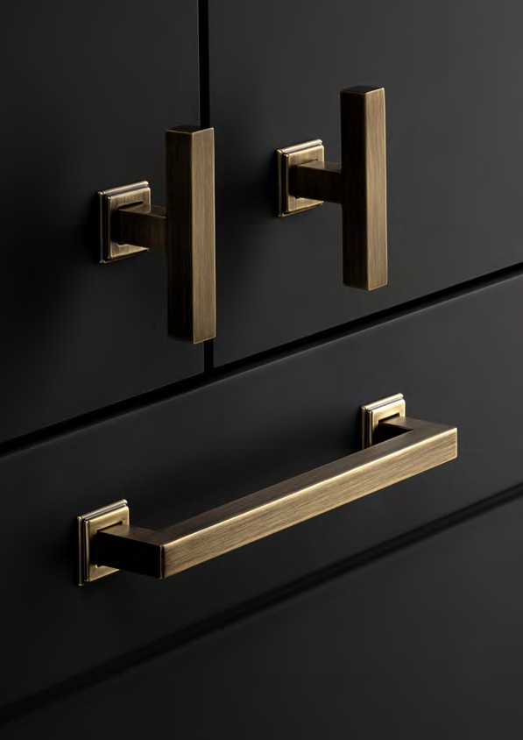
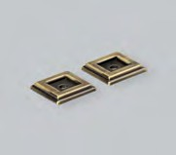
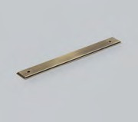
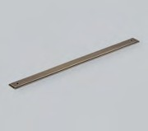

50 51

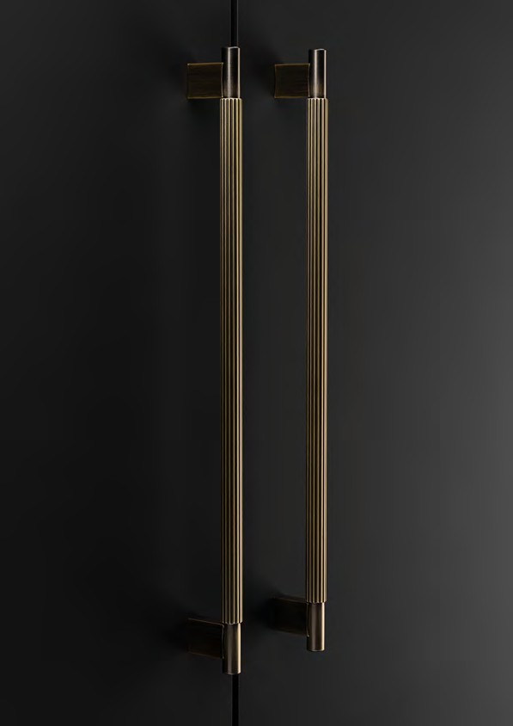

Hudson Collection

Featuring a intricate grooved section and smooth ends on each piece, an impressive juxtaposition
is created through the contrasting textures and balanced proportions.

52 53

8 0 MM T - B AR KNOB

C ODE : GHUK 0 8 0
FINISH CODE
BSB, CP, DBB, MBL
Hudson

PROJECTION
33MM
OVERALL LENGTH
80MM
BAR THICKNESS
12MM

1 6 0 MM PULL HANDLE

C ODE : GHUP 1 6 0
FINISH CODE
BSB, CP, DBB, MBL

HOLE CENTRES
160MM
PROJECTION
33MM
OVERALL LENGTH
186MM
BAR THICKNESS
12MM

3 2 0 MM PULL HANDLE

C ODE : GHUP 3 2 0
FINISH CODE
BSB, CP, DBB, MBL

Hudson Collection

HOLE CENTRES PROJECTION OVERALL LENGTH BAR THICKNESS

320MM
33MM
346MM
12MM

Featuring a intricate grooved section and smooth ends on each piece, an impressive juxtaposition is created through the contrasting textures and balanced proportions.
Made from Aluminum/Zamac. Includes fixings.

FINISHES

BRUSHED SATIN BRASS (BSB)
CHROME
PLATED (CP)
DARK BRUSHED BRASS (DBB)
MATT BLACK
(MBL)

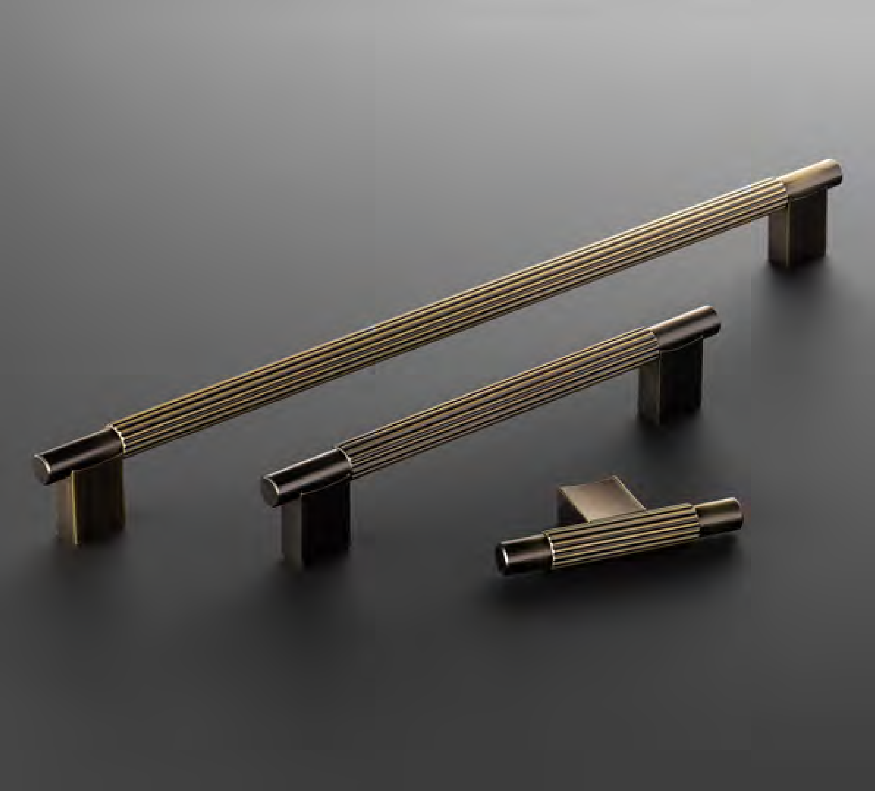
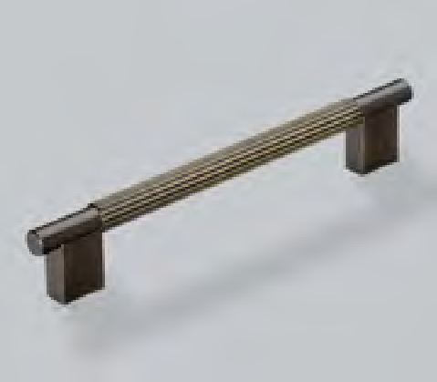
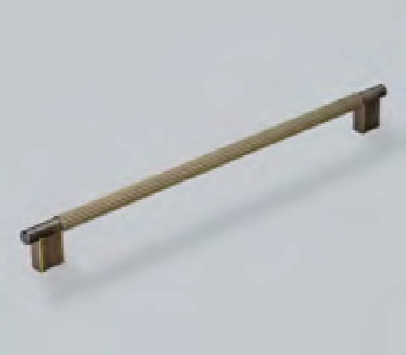
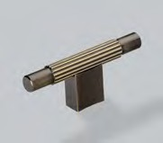
54 55

2 8 MM KNOB

C ODE : GO TK 0 2 8
FINISH CODE
AB, BSB, MBL
Otto

PROJECTION
28MM
KNOB DIAMETER
28MM

9 6 MM CUP HANDLE

C ODE : G OTC 0 9 6
FINISH CODE
AB, BSB, MBL

HOLE CENTRES
96MM
PROJECTION
22MM
OVERALL LENGTH
133MM
HEIGHT
25MM

1 6 0 MM D HANDLE

C ODE : G O T D 160
FINISH CODE
AB, BSB, MBL

Otto Collection

HOLE CENTRES PROJECTION OVERALL LENGTH WIDTH X HEIGHT

160MM
29MM
175MM
9MM X 9MM

With its distinct blend of contemporary and traditional styling, this is the perfect
transitional trio for any door. The perfect choice for those looking for versatile styling options. A touch of urban influence gives this design a unique edge.
Made from Zamac. Includes fixings.

FINISHES

ANTIQUE BRASS (AB)
BRUSHED SATIN BRASS (BSB)
MATT BLACK
(MBL)

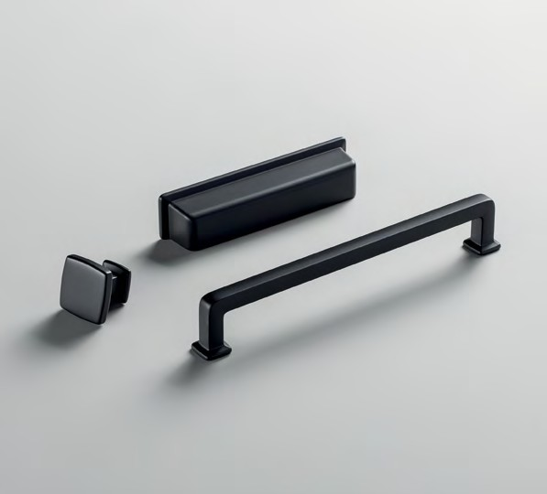
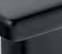
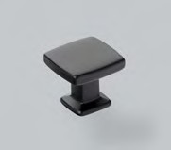
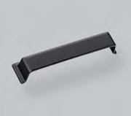
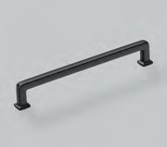
56 57

1 6 0 MM D HANDLE

C ODE : G L U D 160
FINISH CODE
AB, AP, BSB
Lumi

HOLE CENTRES
160MM
PROJECTION
33MM
OVERALL LENGTH
173MM
BAR THICKNESS
13MM

3 2 0 MM D HANDLE

C ODE : G L U D 320
FINISH CODE
AB, AP, BSB

HOLE CENTRES
320MM
PROJECTION
33MM
OVERALL LENGTH
334MM
BAR THICKNESS
13MM

Lumi Collection

A sleek duo with linear detailing, this collection personifies
transitional. Clean lines, sleek profiles and a modern aesthetic, whilst still embracing traditional details that always impress.
Made from Zamac. Includes fixings.

FINISHES
Clean lines, sleek profiles and a modern aesthetic, whilst still embracing traditional
details that always impress.

ANTIQUE BRASS (AB)
ANTIQUE
PEWTER (AP)
BRUSHED SATIN BRASS (BSB)

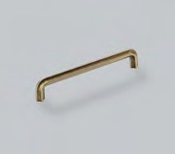
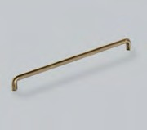
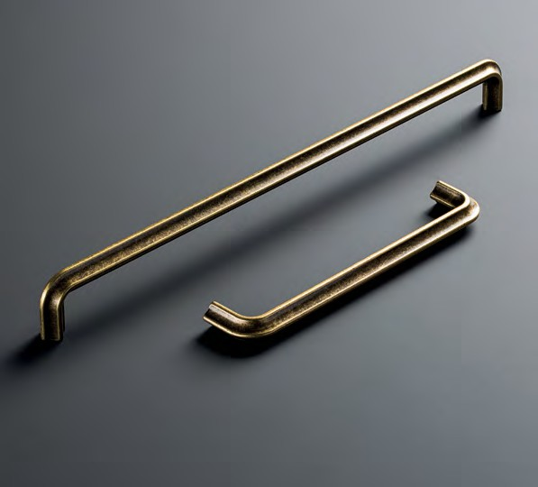
58 59

3 2 MM KNOB

C ODE : GNEK 0 3 2
FINISH CODE
BSB, CP, DN, MBL
Newport

PROJECTION
28MM
KNOB DIAMETER
32MM

1 6 0 MM PULL HANDLE

C ODE : GNEP 1 6 0
FINISH CODE
BSB, CP, DN, MBL

HOLE CENTRES
160MM
PROJECTION
29MM
OVERALL LENGTH
172MM
WIDTH X HEIGHT
9MM X 8MM

3 2 0 MM PULL HANDLE

C ODE : GNEP 3 2 0
FINISH CODE
BSB, CP, DN, MBL

Newport Collection

HOLE CENTRES PROJECTION OVERALL LENGTH WIDTH X HEIGHT

320MM
29MM
332MM
9MM X 8MM

With it’s understated detailing and refined form, this collection
embodies sophistication. Subtle contours add tactility and visual depth, making this the perfect hardware choice for bedroom spaces.
Made from Zamac. Includes fixings.

FINISHES

BRUSHED SATIN BRASS (BSB)
CHROME
PLATED (CP)
DULL NICKEL
(DN)
MATT BLACK
(MBL)

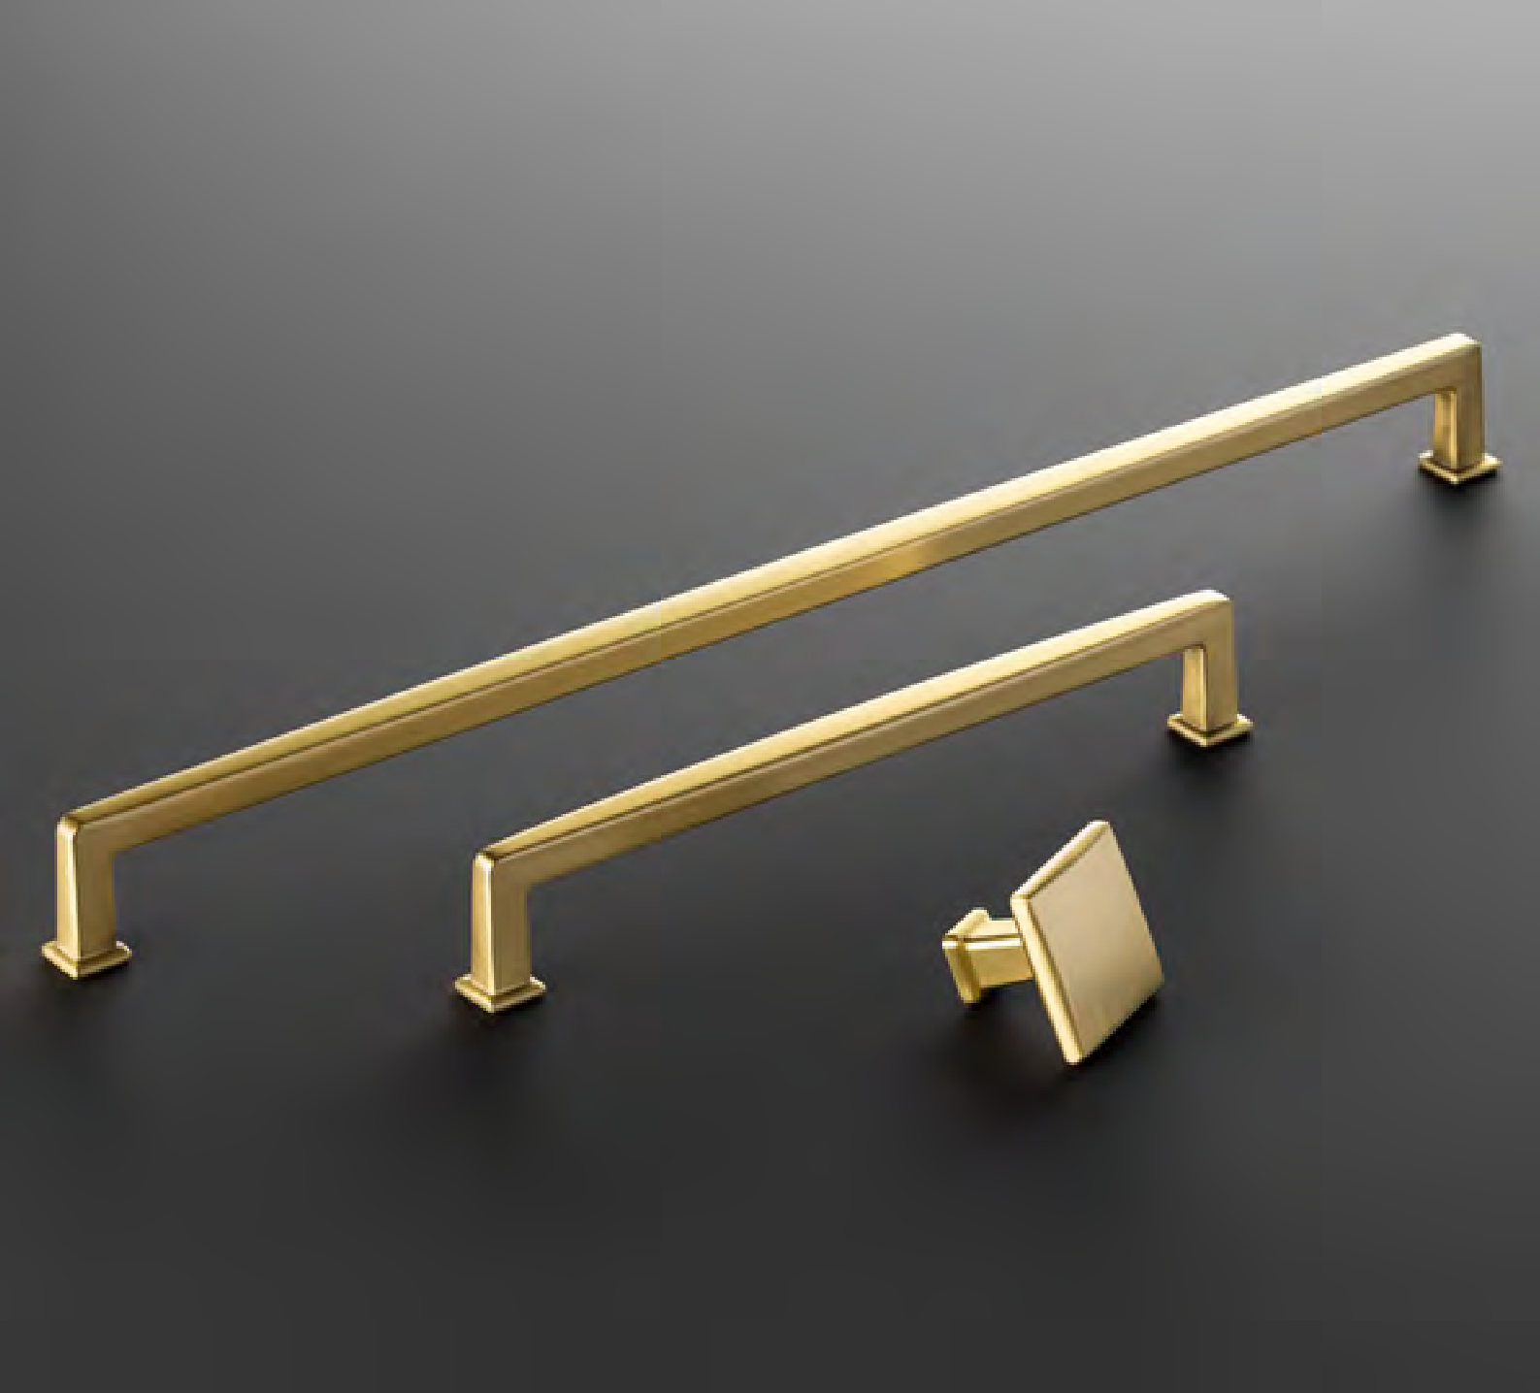
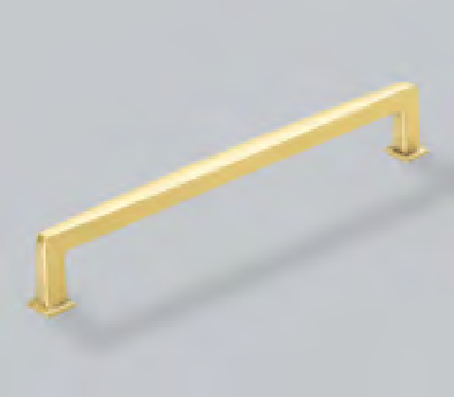
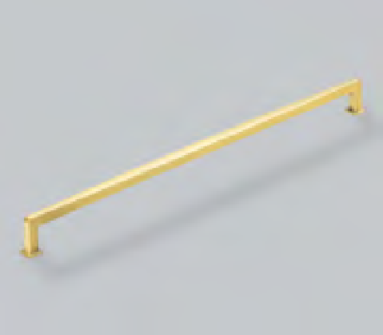
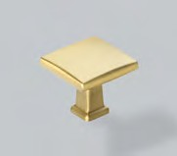
60 61

6 0 MM T - B AR KNOB

C ODE : GC AK 0 6 0 PN
FINISH CODE
PN
Casper

PROJECTION
37MM
OVERALL LENGTH
60MM
BAR THICKNESS
14MM

1 2 8 MM B AR HANDLE

C ODE : GC AB 1 2 8 PN
FINISH CODE
PN

HOLE CENTRES
128MM
PROJECTION
37MM
OVERALL LENGTH
168MM
BAR THICKNESS
14MM

1 9 2 MM B AR HANDLE

C ODE : GC AB 1 9 2 PN
FINISH CODE
PN

Casper Collection

HOLE CENTRES PROJECTION OVERALL LENGTH BAR THICKNESS

192MM
37MM
232MM
14MM

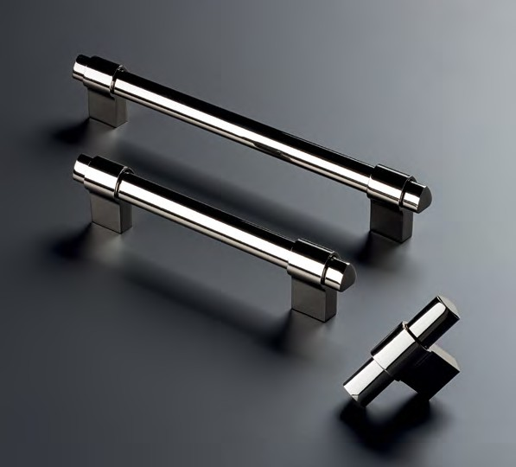
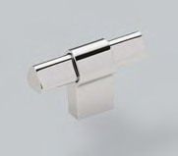
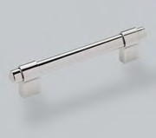
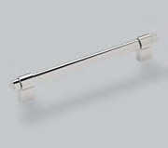

Luxury, redefined. The soft triangular curved bar gives this collection a unique shape and timeless feel as it merges with the delicate up and over clasp from the foot.
Made from Aluminium. Fixings sold separately.

FINISHES

POLISHED NICKEL (PN)
62 63

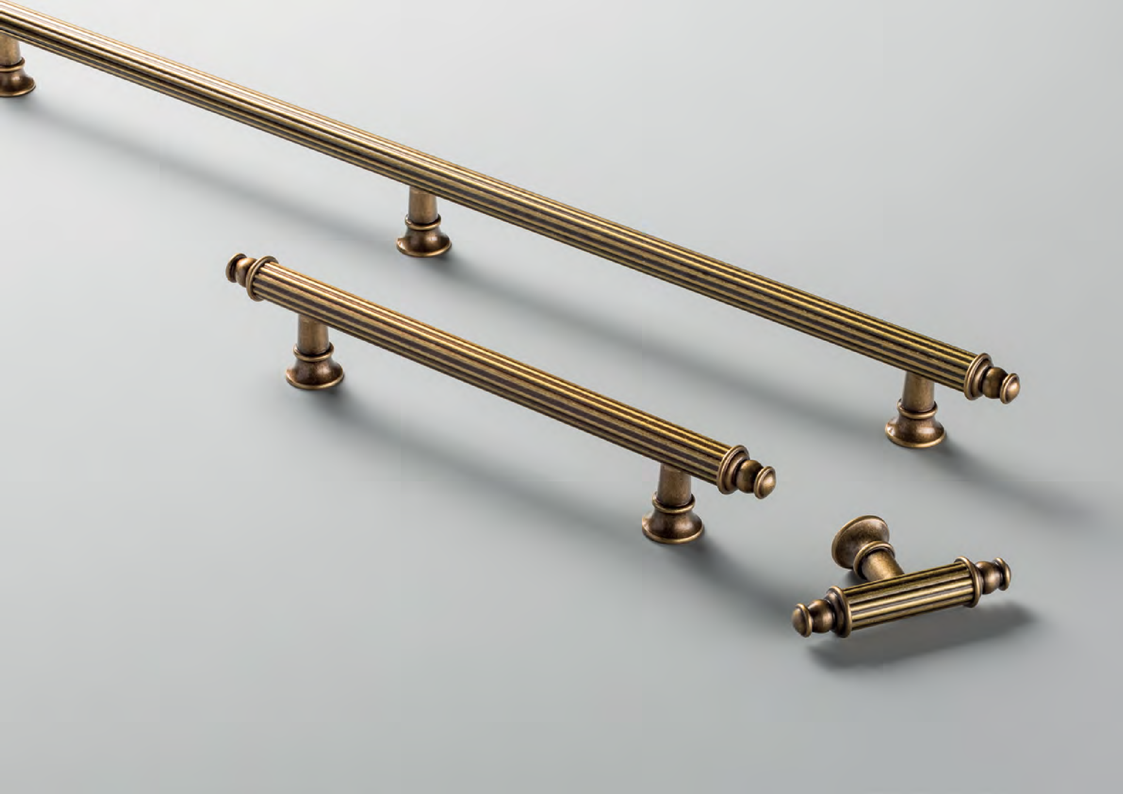

Traditional

64 65

2 9 MM KNOB

C ODE : GGRK 0 2 9
FINISH CODE
BB, BN, BSB, CP, MBL, ORB, PN
Greenwich

PROJECTION
39MM
KNOB DIAMETER
29MM

6 4 MM CUP HANDLE

C ODE : GGR C 0 6 4
FINISH CODE
BB, BN, BSB, CP, MBL, ORB, PN

HOLE CENTRES
64MM
PROJECTION
23MM
OVERALL LENGTH
84MM
HEIGHT
42MM

1 6 0 MM PULL HANDLE

C ODE : GGRP 1 6 0
FINISH CODE
BB, BN, BSB, CP, MBL, ORB, PN

Greenwich Collection

HOLE CENTRES
160MM

PROJECTION
39MM

OVERALL LENGTH
190MM

The timeless and sophisticated design elements of British architecture inspired the
creation of Greenwich. With it’s subtle curves and understated elegance, the collection captures the essence of classic British style that has stood the test of time.
Made from Brass. Includes fixings.

FINISHES

3 2 0 MM PULL HANDLE

C ODE : GGRP 3 2 0
FINISH CODE
BB, BN, BSB, CP, MBL, ORB, PN

BURNISHED BRASS (BB)

BRUSHED NICKEL (BN)

BRUSHED SATIN BRASS (BSB)

CHROME
PLATED (CP)

MATT BLACK
(MBL)

OIL RUBBED BRONZE (ORB)

POLISHED NICKEL (PN)
HOLE CENTRES
320MM
PROJECTION
44MM
OVERALL LENGTH
350MM

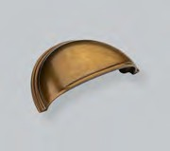
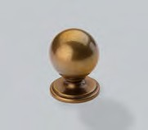
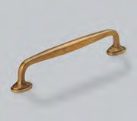
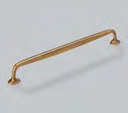
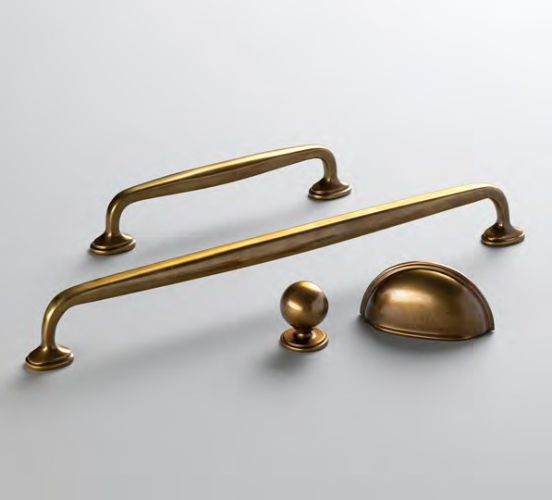
66 67

York Collection

With its intricate curve and clean lines, the design works with both solid surface and wood shelves using the included fixing pack. Finishes match Ark, Felix, Fleur & Greenwich.
Made from Brass. Includes matching fixings.
30kg load capacity per bracket.

FINISHES

BURNISHED | BRUSHED | BRUSHED SATIN | CHROME | MATT BLACK | OIL RUBBED | POLISHED
BRASS (BB) | NICKEL (BN) | BRASS (BSB) | PLATED (CP) | (MBL) | BRONZE (ORB) | NICKEL (PN)

1 9 5 MM SHELF BRA CKET

C ODE : GYO S B 2 4 5
FINISH CODE
BB, BN, BSB, CP, MBL, ORB, PN

HOLE CENTRES
255MM
PROJECTION
204MM
SHELF SUPPORT
195MM
HEIGHT
282MM

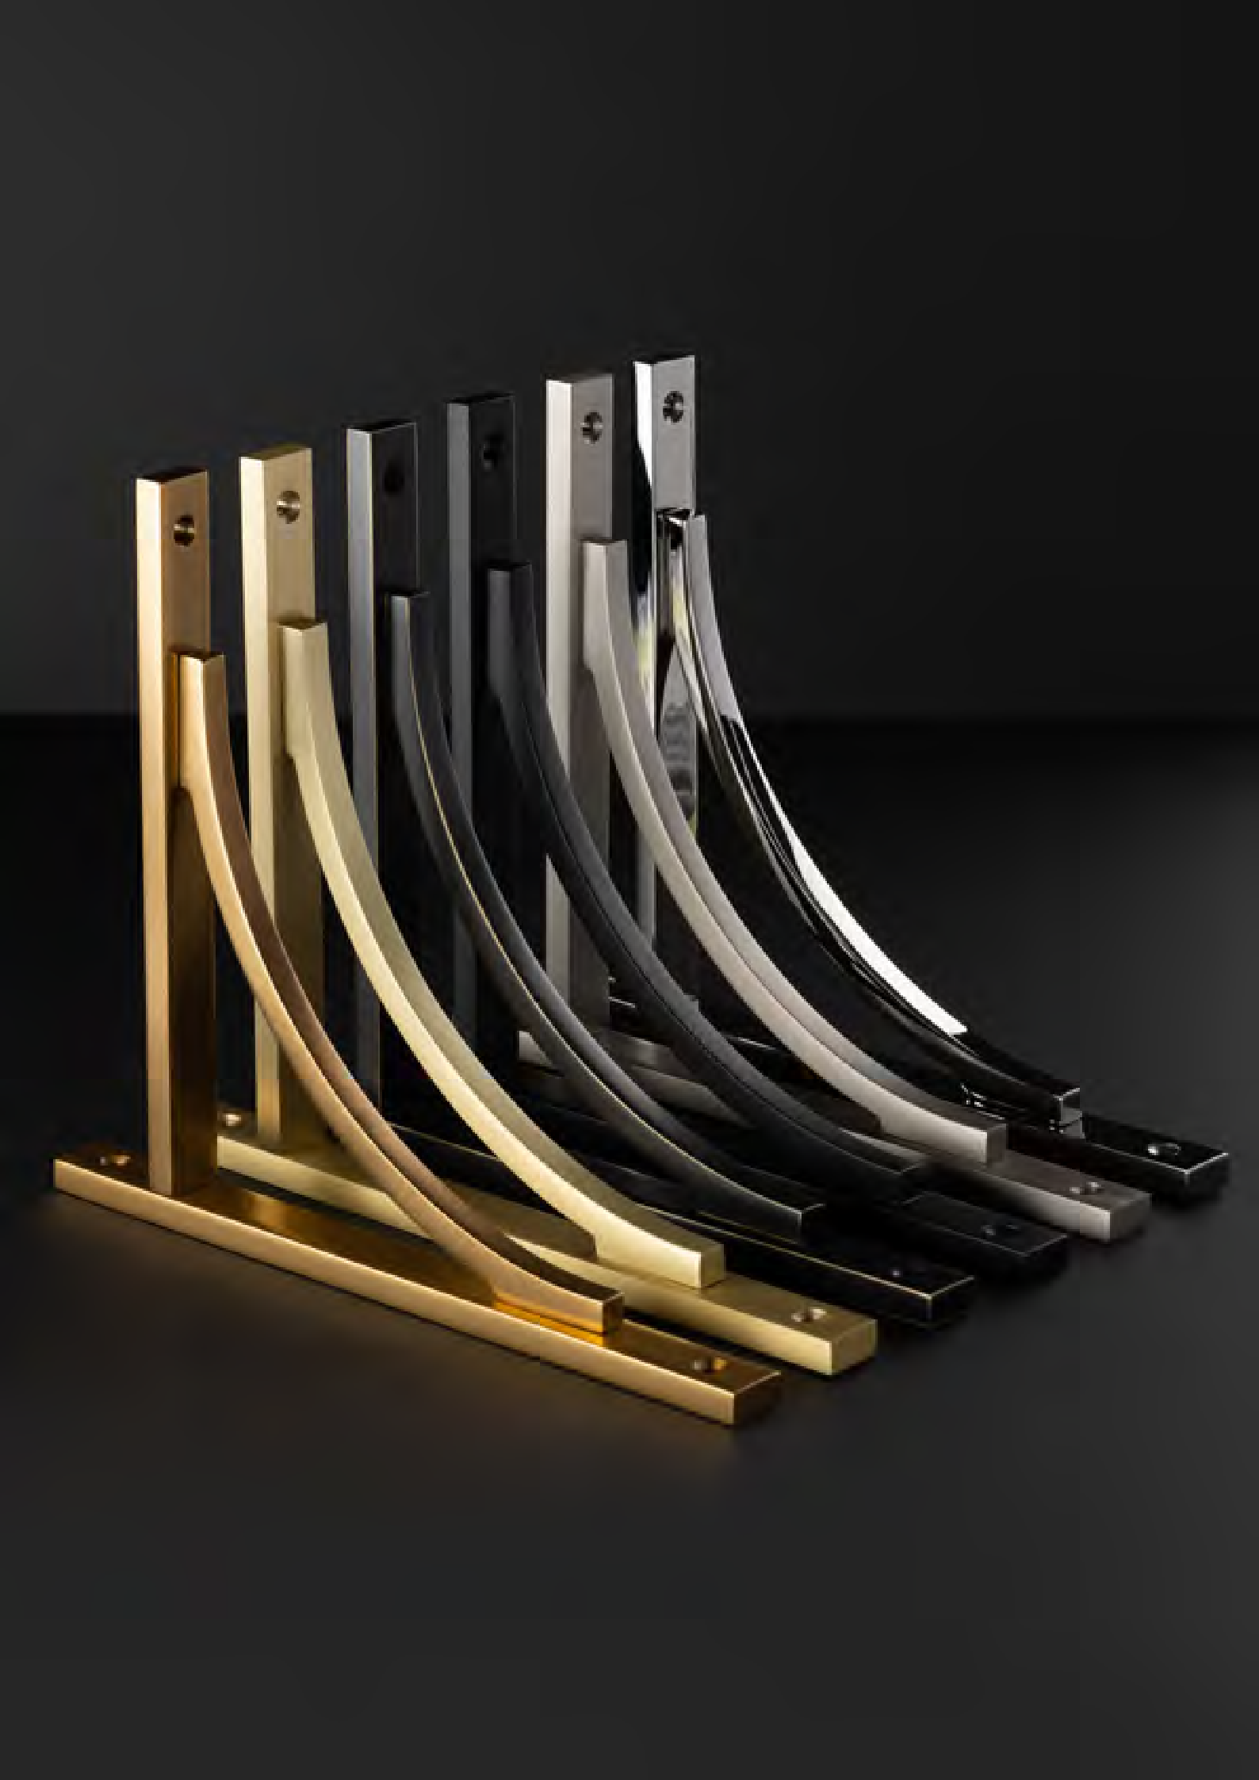
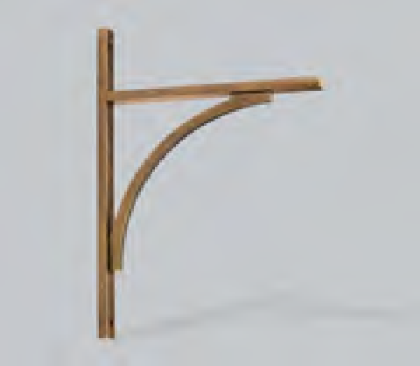
68 69

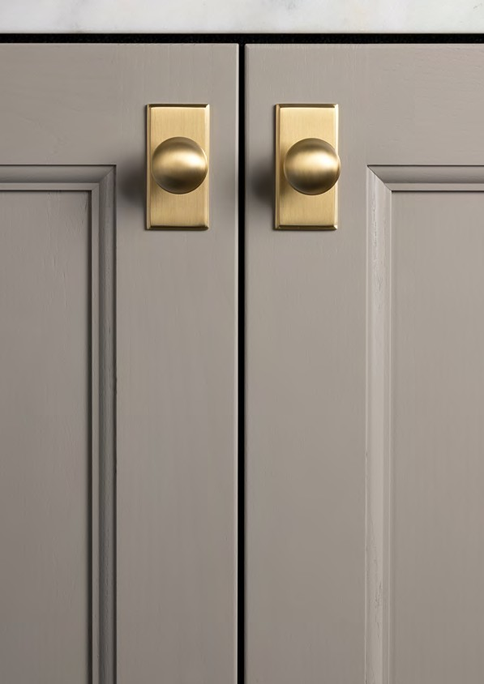

Callcott Collection

Quintessentially British, this heritage collection
personifies Hendel & Hendel’s philosophy of dedicated design and craftsmanship. Hand finished, the cup
and knob combination incorporates defining stepped details on the back plate to add a unique touch.
Choose from three considered cup sizes and three knob configurations, for ultimate design flexibility.

70 71

3 4 MM KNOB

C ODE : GC ALK 0 3 4
FINISH CODE
BB, BN, BSB, DBB, MBL, PN
Callcott

PROJECTION
33MM
KNOB DIAMETER
34MM

3 8 MM SQU ARE B A CKPL ATE

C ODE : GC ALBP 0 3 8
FINISH CODE
BB, BN, BSB, DBB, MBL, PN

HOLE CENTRES
64MM
OVERALL LENGTH
38MM
HEIGHT
38MM
BACKPLATE THICKNESS
4MM

7 6 MM REC TANGLE B A CKPL ATE

C ODE : GC ALBP 0 7 6
FINISH CODE
BB, BN, BSB, DBB, MBL, PN

Callcott Collection

HOLE CENTRES
64MM

OVERALL LENGTH
76MM

HEIGHT
38MM

BACKPLATE THICKNESS
4MM

Quintessentially British, this heritage collection personifies Hendel & Hendel’s philosophy of dedicated design and
craftsmanship. Hand finished, the cup and knob combination incorporates defining stepped details on the back plate to add a unique touch. Choose from three considered cup sizes and three knob configurations, for ultimate design flexibility.
Made from Brass. Includes fixings.

FINISHES

6 4 MM CUP HANDLE

C ODE : GC AL C 0 6 4
FINISH CODE
BB, BN, BSB, DBB, MBL, PN

BURNISHED BRASS (BB)

BRUSHED NICKEL (BN)

BRUSHED SATIN BRASS (BSB)

DARK BRUSHED BRASS (DBB)

MATT BLACK
(MBL)

POLISHED NICKEL (PN)
HOLE CENTRES
64MM
PROJECTION
21MM
OVERALL LENGTH
92MM
HEIGHT
40MM

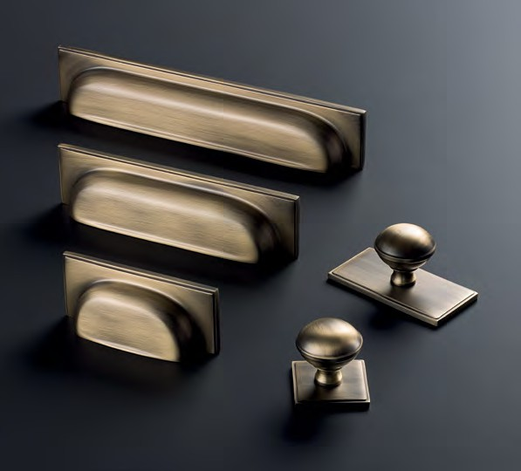
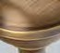
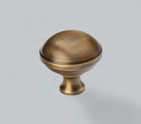
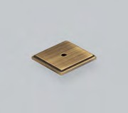
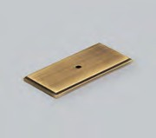
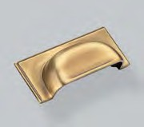
72 73

1 2 8 MM CUP HANDLE

C ODE : G C A L C 128
FINISH CODE
BB, BN, BSB, DBB, MBL, PN
Callcott

HOLE CENTRES
128MM
PROJECTION
21MM
OVERALL LENGTH
156MM
HEIGHT
40MM

1 9 2 MM CUP HANDLE

C ODE : G C A L C 192
FINISH CODE
BB, BN, BSB, DBB, MBL, PN

HOLE CENTRES
192MM
PROJECTION
21MM
OVERALL LENGTH
220MM
HEIGHT
40MM

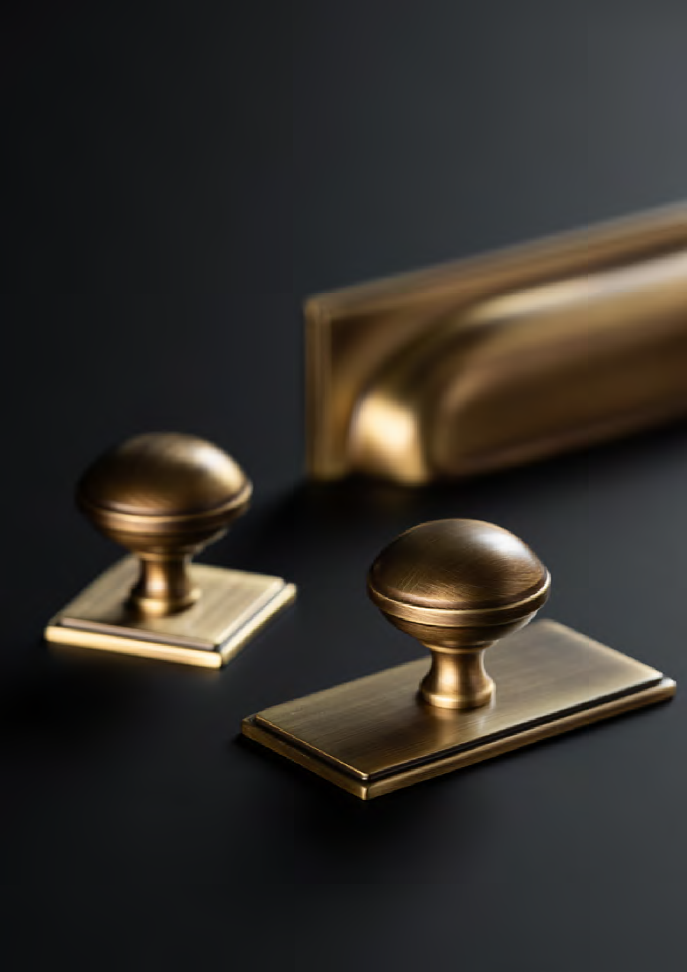
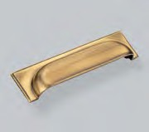
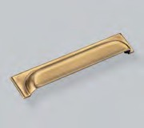

Quintessentially British, made from Brass.

74 75

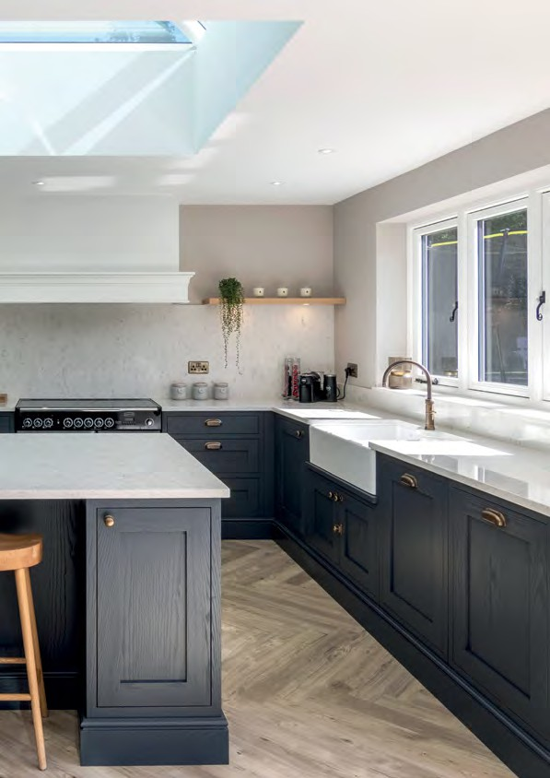

Hampton Collection

A heritage design classic, the collection works effortlessly with shaker cabinetry.
Choose from one in five finishes including timeless Bronze.

76 Image Courtesy of Sherwin Hall Kitchens 77

3 2 MM KNOB

C ODE : GHAK 0 3 2
FINISH CODE
BRO, BSB, DN, MBL, PN
Hampton

PROJECTION
37MM
KNOB DIAMETER
32MM

9 6 MM CUP HANDLE

C ODE : GHA C 0 9 6
FINISH CODE
BRO, BSB, DN, MBL, PN

HOLE CENTRES
96MM
PROJECTION
23MM
OVERALL LENGTH
122MM
HEIGHT
39MM

1 6 0 MM CUP HANDLE

C ODE : G H A C 160
FINISH CODE
BRO, BSB, DN, MBL, PN

Hampton Collection

HOLE CENTRES
160MM

PROJECTION
24MM

OVERALL LENGTH
195MM

HEIGHT
42MM

A heritage design classic, the collection works effortlessly with
shaker cabinetry. Choose from one in five finishes including timeless Bronze.
Made from Zamac. Includes fixings.

FINISHES

1 6 0 MM D HANDLE

C ODE : GHAD 1 6 0
FINISH CODE
BRO, BSB, DN, MBL, PN

BRONZE
(BRO)

BRUSHED SATIN BRASS (BSB)

DULL NICKEL
(DN)

MATT BLACK
(MBL)

POLISHED NICKEL (PN)
HOLE CENTRES
160MM
PROJECTION
27MM
OVERALL LENGTH
167MM
WIDTH X HEIGHT
17MM X 5MM

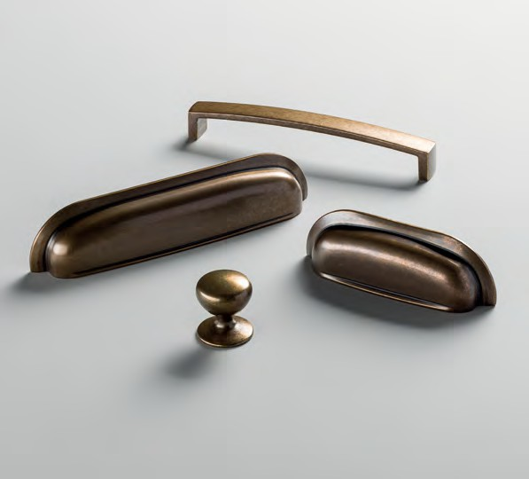
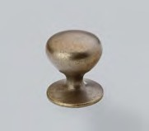
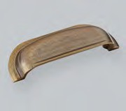
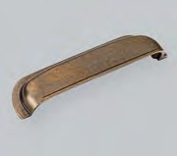
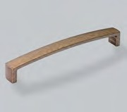
78 79

Jago

Jago Collection

Designed to elevate traditional spaces, with its soft undulating lines and considered form.
Made from Zamac. Includes fixings.

FINISHES

ANTIQUE BRASS (AB)
ANTIQUE
PEWTER (AP)
BRUSHED SATIN BRASS (BSB)
CHROME
PLATED (CP)

1 6 0 MM D HANDLE

C ODE : G J A D 160
FINISH CODE
AB, AP, BSB, CP

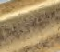
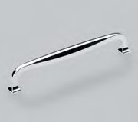
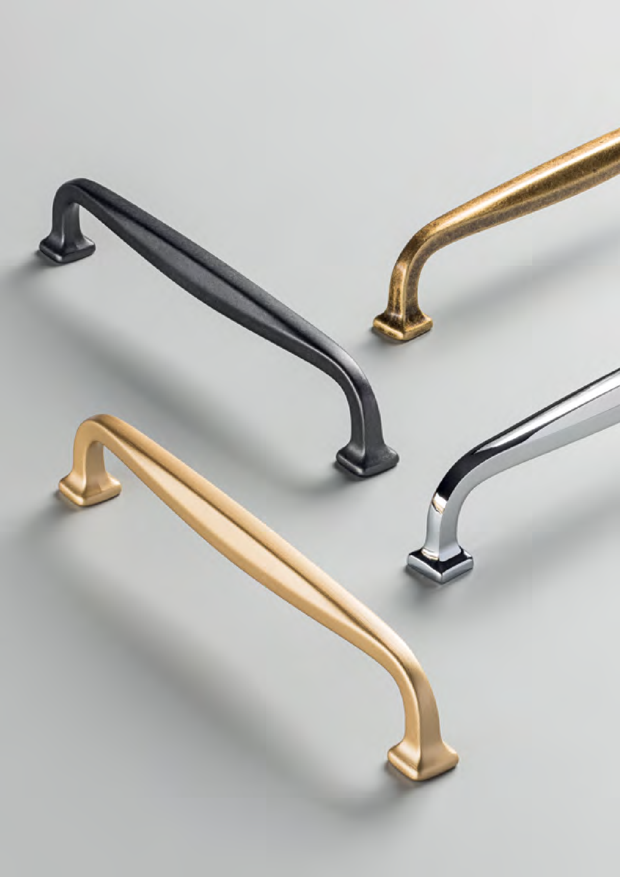
HOLE CENTRES
160MM
80
PROJECTION
33MM
OVERALL LENGTH
175MM
WIDTH X HEIGHT
11MM X 12MM
81

3 8 MM KNOB

C ODE : G T R K 03 8
FINISH CODE
AP, BRO, BSB, DBB, DN, MBL, PN
Trafalgar

PROJECTION
37MM
KNOB DIAMETER
38MM

6 4 MM CUP HANDLE

C ODE : G T R C 0 6 4
FINISH CODE
AP, BRO, BSB, DBB, DN, MBL, PN

HOLE CENTRES
64MM
PROJECTION
29MM
OVERALL LENGTH
102MM
HEIGHT
47MM

9 6 MM BO W HANDLE

C ODE : G TRB 0 9 6
FINISH CODE
AP, BRO, BSB, DBB, DN, MBL, PN

Trafalgar Collection

HOLE CENTRES PROJECTION OVERALL LENGTH WIDTH X HEIGHT

96MM
27MM
142MM
18MM X 6MM

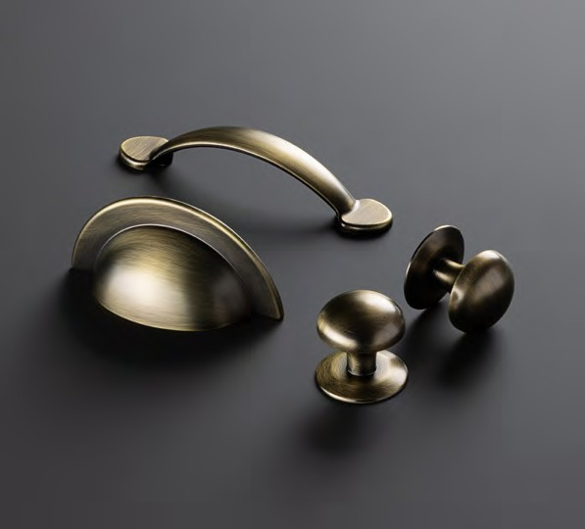
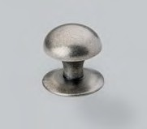
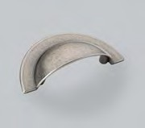
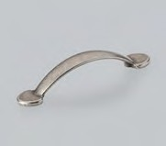

A timeless classic, reinvented. Featuring sophisticated curves and exquisite finishes. This is an essential collection with generous design proportions, manufactured with meticulous care and attention to fine detail.
Made from Zamac. Includes fixings.

FINISHES

83
 | ANTIQUE  PEWTER (AP) | BRONZE  (BRO) | BRUSHED SATIN DARK BRUSHED BRASS (BSB) BRASS (DBB) | DULL NICKEL  (DN) | MATT BLACK  (MBL) | POLISHED NICKEL (PN)
82

7 8 MM T - B AR KNOB

C ODE : GFIK 0 7 8
FINISH CODE
AB
Finsbury

PROJECTION
40MM
OVERALL LENGTH
78MM
BAR THICKNESS
14MM

1 6 0 MM B AR HANDLE

C ODE : GFIB 1 6 0
FINISH CODE
AB

HOLE CENTRES
160MM
PROJECTION
40MM
OVERALL LENGTH
238MM
BAR THICKNESS
14MM

4 4 8 MM B AR HANDLE

C ODE : GFIB 4 4 8
FINISH CODE
AB

Finsbury Collection

HOLE CENTRES PROJECTION OVERALL LENGTH BAR THICKNESS

224MM X 2
40MM
526MM
14MM

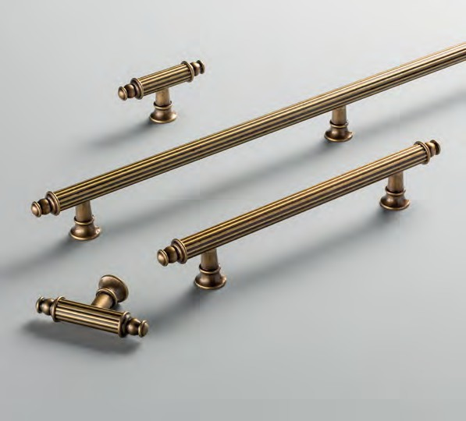
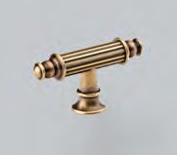
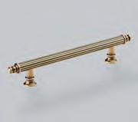
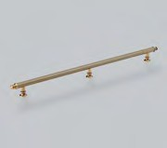

Designed to captivate, this majestic collection features a detailed
linear bar, finial ends and fluted posts. The combination of a gold hue and brown patina creates an opulent antique brass finish.
Made from Brass. Includes fixings.

FINISHES

ANTIQUE BRASS (AB)
84 85

3 2 MM KNOB

C ODE : GFLK 0 3 2
FINISH CODE
BB, BN, BSB, MBL, PN
Fleur

PROJECTION
34MM
KNOB DIAMETER
32MM

9 6 MM CUP HANDLE

C ODE : GFL C 0 9 6
FINISH CODE
BB, BN, BSB, MBL, PN

HOLE CENTRES
96MM
PROJECTION
19MM
OVERALL LENGTH
139MM
HEIGHT
31MM

Fleur Collection

This beautiful two-piece collection features elegant soft lines and works perfectly on shaker cabinetry.
Made from Brass. Includes fixings.
A tasteful addition to any home.
The refined geometry of
the Fleur collection will lift traditional cabinetry.

FINISHES

BURNISHED BRASS (BB)
BRUSHED NICKEL (BN)
BRUSHED SATIN BRASS (BSB)
MATT BLACK
(MBL)
POLISHED NICKEL (PN)

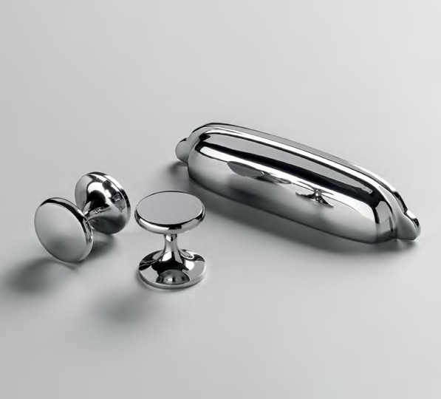
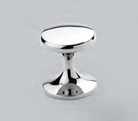
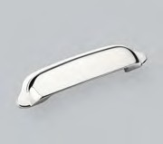
86 87

3 0 MM KNOB

C ODE : GCHK 0 3 0
FINISH CODE
BN, CP
Charlbury

PROJECTION
27MM
KNOB DIAMETER
30MM

7 6 MM CUP HANDLE

C ODE : GCHC 0 7 6
FINISH CODE
BN, CP

HOLE CENTRES
76MM
PROJECTION
29MM
OVERALL LENGTH
106MM
OVERALL HEIGHT
41MM

C OC O 3 8 MM KNOB

C ODE : GC OK 0 3 8
FINISH CODE
BN, CP
Coco

Charlbury Collection

PROJECTION KNOB DIAMETER

26MM 38MM

An established all-time favourite. This cup will flush fit onto the cabinet
for ease of fitting. Paired with a delicate cabinet knob for understated appeal.
The perfect accompaniment for a wide range of furniture designs.
Made from Zamac. Includes fixings.

FINISHES

BRUSHED NICKEL (BN)
CHROME
PLATED (CP)

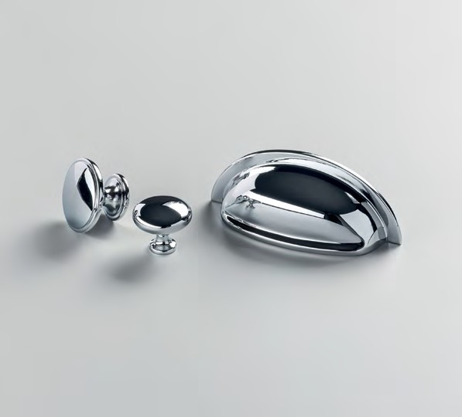
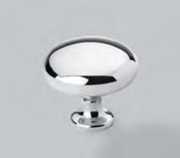
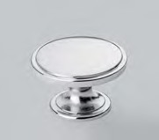
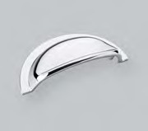
88 89

3 1 MM KNOB

C ODE : GHEK 0 3 1
FINISH CODE
AB, MBL
Hebe

PROJECTION
22MM
KNOB DIAMETER
31MM

1 2 8 MM B AR HANDLE

C ODE : GHEB 1 2 8
FINISH CODE
AB, MBL

HOLE CENTRES
128MM
PROJECTION
32MM
OVERALL LENGTH
143MM
BAR THICKNESS
14MM

Hebe Collection

With its concentric detailing and traditional design cues, Hebe suits shaker cabinetry perfectly.
Made from Zamac. Includes fixings.
The Hebe collection complements traditional design aesthetics with its refined detailing and
timeless finishes.

FINISHES

ANTIQUE BRASS (AB)
MATT BLACK
(MBL)

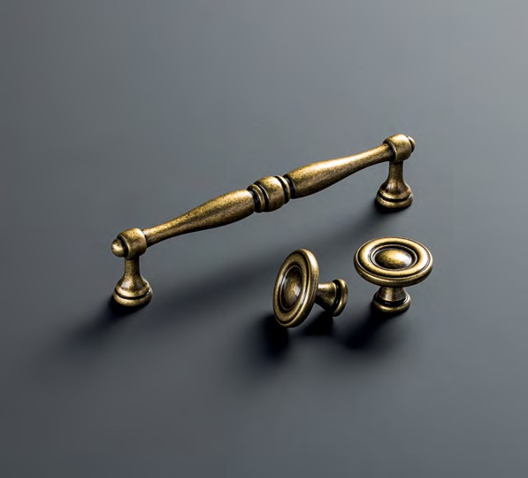
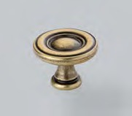
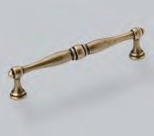
90 91

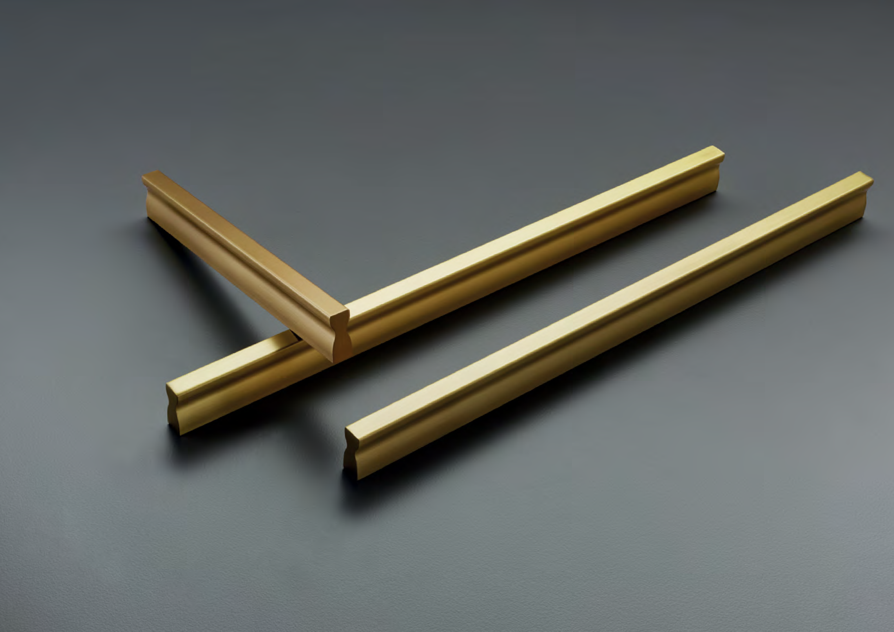
Contemporary

92 93

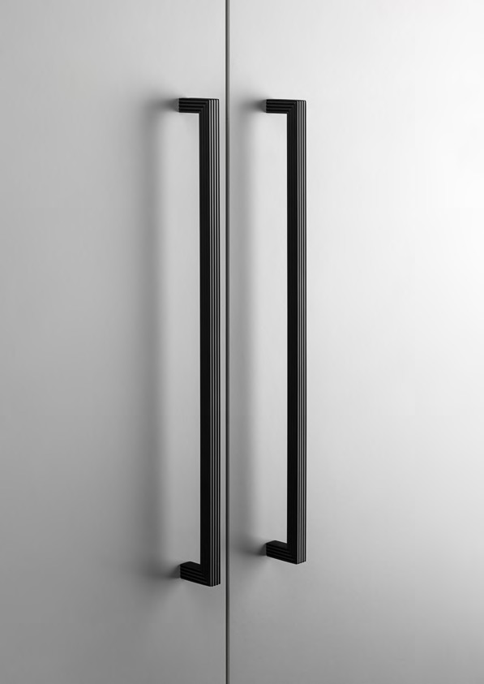

Battersea Collection

Embodying the iconic design of Battersea Power Station, the collection is characterised by its distinctive linear grooves. The texture enhances the simple silhouette to give a tactile, striking finish. Where Art Deco styling
meets contemporary, the epitome of form and function.

94 95

6 0 MM T - B AR KNOB

C ODE : G B AT K 060
FINISH CODE
BSB, CP, DBB, DN, MBL
Battersea

PROJECTION
30MM
OVERALL LENGTH
60MM
BAR THICKNESS
10MM

1 6 0 MM PULL HANDLE

C ODE : G B AT P 160
FINISH CODE
BSB, CP, DBB, DN, MBL

HOLE CENTRES
160MM
PROJECTION
30MM
OVERALL LENGTH
169MM
BAR THICKNESS
10MM

3 2 0 MM PULL HANDLE

C ODE : G B AT P 320
FINISH CODE
BSB, CP, DBB, DN, MBL

Battersea Collection

HOLE CENTRES PROJECTION OVERALL LENGTH BAR THICKNESS

320MM
30MM
329MM
10MM

Embodying the iconic design of Battersea Power Station, the collection is characterised by its
distinctive linear grooves. The texture enhances the simple silhouette to give a tactile, striking finish.
Where Art Deco styling meets contemporary, the epitome of form and function.
Made from Zamac. Includes fixings.

FINISHES

BRUSHED SATIN BRASS (BSB)
CHROME
PLATED (CP)
DARK BRUSHED BRASS (DBB)
DULL NICKEL
(DN)
MATT BLACK
(MBL)

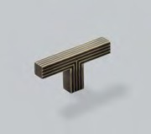
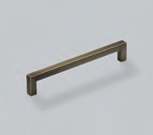
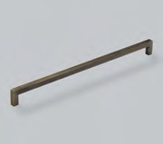
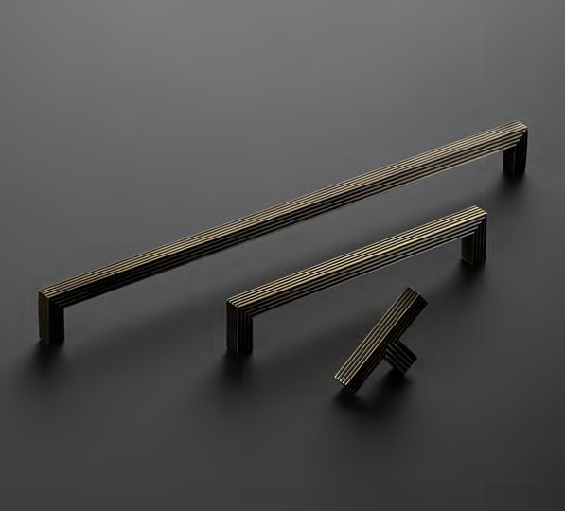
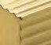
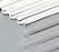
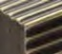
96 97

3 2 MM HANDLE

C ODE : G JUP 0 3 2
FINISH CODE
BSB, PN
Jura

HOLE CENTRES
32MM
PROJECTION
23MM
OVERALL LENGTH
46MM
BAR THICKNESS
10MM

1 6 0 MM HANDLE

C ODE : G J U P 160
FINISH CODE
BSB, PN

HOLE CENTRES
160MM
PROJECTION
23MM
OVERALL LENGTH
174MM
BAR THICKNESS
10MM

3 2 0 MM HANDLE

C ODE : G J U P 320
FINISH CODE
BSB, PN

Jura Collection

HOLE CENTRES
320MM

PROJECTION
23MM

OVERALL LENGTH
334MM

BAR THICKNESS
10MM

A modest yet sophisticated collection. Understated
with its ridged indent design feature to add that unique finishing touch and make this piece truly functional.
Made from Aluminium. Includes fixings.

FINISHES

5 7 6 MM HANDLE

C ODE : G JUP 5 7 6
FINISH CODE
BSB, PN

BRUSHED SATIN BRASS (BSB)

POLISHED NICKEL (PN)
HOLE CENTRES
288MM X 2
PROJECTION
23MM
OVERALL LENGTH
622MM
BAR THICKNESS
10MM

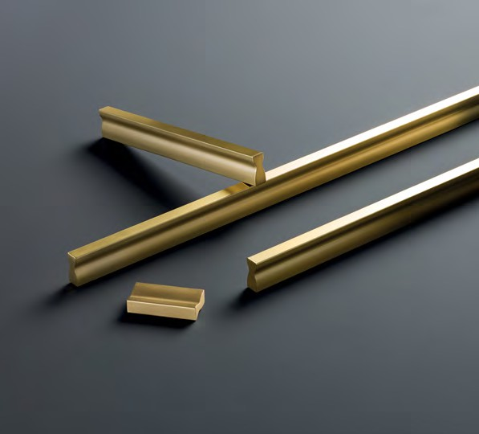
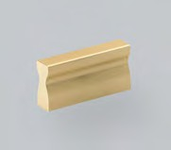
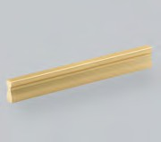
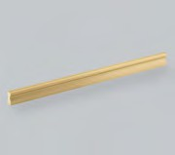
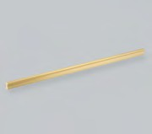
98 99

Reba Collection

Inspired by the power of nature’s elements, this textured piece is wonderfully tactile, available in three exquisite finishes.
Perfectly suited for contemporary furniture applications.
Made from Zamac. Includes fixings.

FINISHES

POLISHED NICKEL (PN)
SATIN BRASS
(SB)
SATIN COPPER
(SC)

1 9 2 MM B AR HANDLE

C ODE : GREB 1 9 2
FINISH CODE
PN, SB, SC

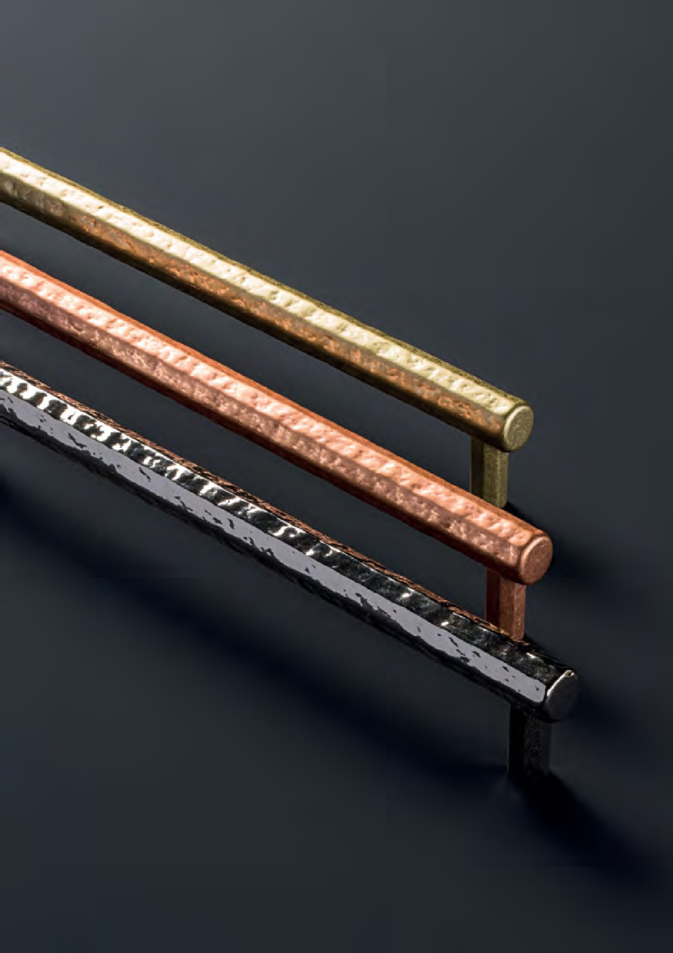
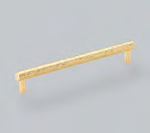

100
HOLE CENTRES
192MM
PROJECTION
33MM
OVERALL LENGTH
211MM
BAR THICKNESS
13MM

101

6 4 MM PROFILE HANDLE

C ODE : GEDP 0 6 4
FINISH CODE
BSB, DBB, MBL, PN
Edison

HOLE CENTRES
64MM
PROJECTION
41MM
OVERALL LENGTH
100MM
HEIGHT
18MM

1 2 8 MM PROFILE HANDLE

C ODE : GEDP 1 2 8
FINISH CODE
BSB, DBB, MBL, PN

HOLE CENTRES
128MM
PROJECTION
41MM
OVERALL LENGTH
200MM
HEIGHT
18MM

2 5 6 MM PROFILE HANDLE

C ODE : GEDP 2 5 6
FINISH CODE
BSB, DBB, MBL, PN

Edison Collection

HOLE CENTRES
256MM

PROJECTION
41MM

OVERALL LENGTH
351MM

HEIGHT
18MM

Clean, elegant and distinctive. This pull collection promises to add a soft, sleek accent to your modern interior. With its elegantly tapered edges, this design is beautifully
balanced and works seamlessly on both slab and shaker style doors.
Made from Aluminium. Includes fixings.

FINISHES

8 6 4 MM PROFILE HANDLE

C ODE : GEDP 8 6 4
FINISH CODE
BSB, DBB, MBL, PN

BRUSHED SATIN BRASS (BSB)

DARK BRUSHED BRASS (DBB)

MATT BLACK
(MBL)

POLISHED NICKEL (PN)
HOLE CENTRES
288MM X 3
PROJECTION
41MM
OVERALL LENGTH
900MM
HEIGHT
18MM

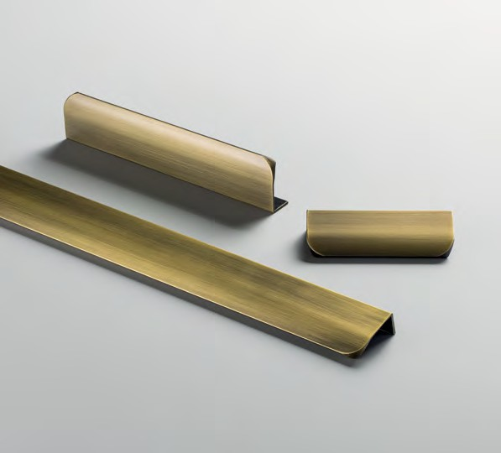
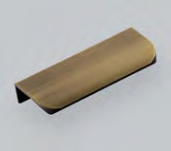
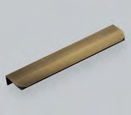
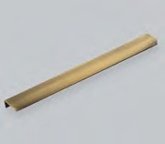
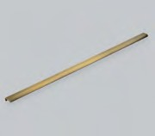
102 103

1 2 8 MM PROFILE HANDLE

C ODE : GLIP 1 2 8
FINISH CODE
BN, BSB, MBL
Lincoln

HOLE CENTRES
128MM
PROJECTION
43MM
OVERALL LENGTH
200MM
HEIGHT
20MM

1 9 2 MM PROFILE HANDLE

C ODE : GLIP 1 9 2
FINISH CODE
BN, BSB, MBL

HOLE CENTRES
192MM
PROJECTION
43MM
OVERALL LENGTH
250MM
HEIGHT
20MM

7 6 8 MM PROFILE HANDLE

C ODE : GLIP 7 6 8
FINISH CODE
BN, BSB, MBL

Lincoln Collection

HOLE CENTRES PROJECTION OVERALL LENGTH HEIGHT

384MM X 2
43MM
800MM
20MM

A minimalist, wrap around profile handle.
Lincoln is designed for contemporary spaces.
Made from Aluminium. Includes fixings.

FINISHES

BRUSHED NICKEL (BN)
BRUSHED SATIN BRASS (BSB)
MATT BLACK
(MBL)

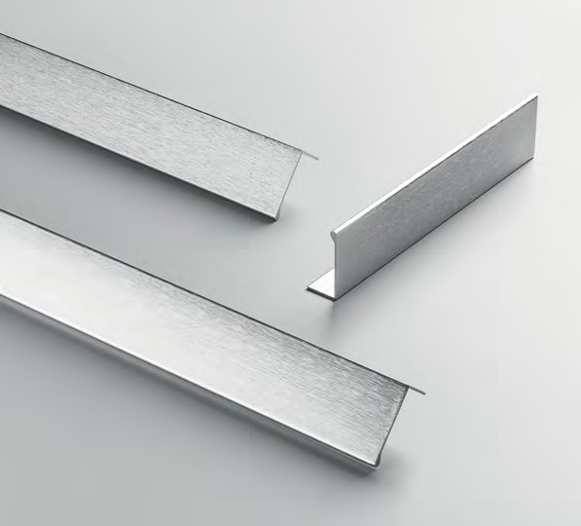
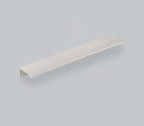
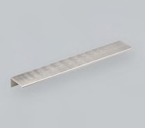
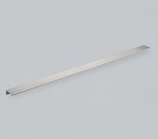
104 105

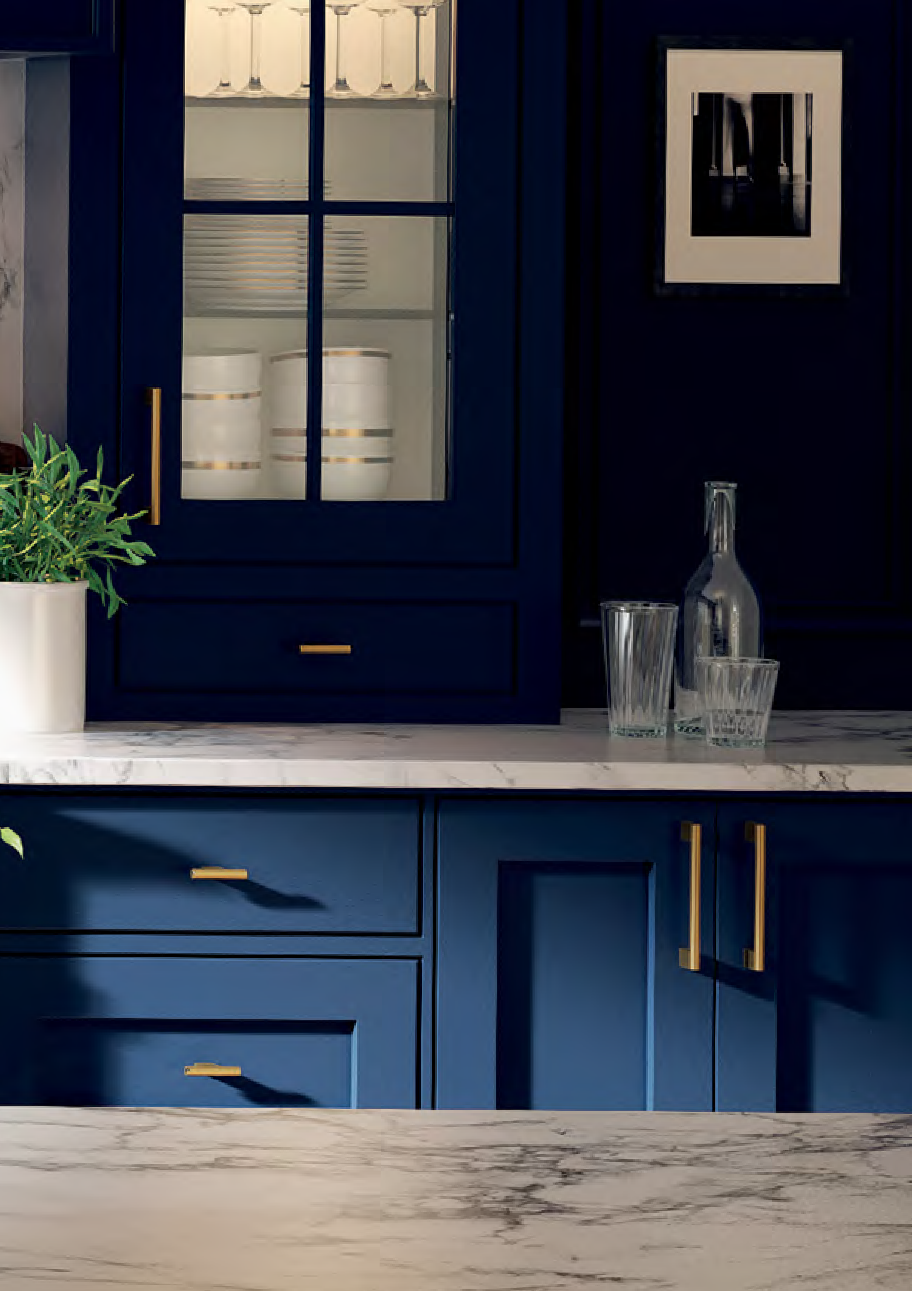

Kellas Collection

Achieving the perfect balance of design and functionality, Kellas suits a wide range of design applications. The knurled texture adds a refined tactile feel to the design.

106 107

6 0 MM T - B AR KNOB

C ODE : GKEK 0 6 0
FINISH CODE
BA, MBL, SB
Kellas

PROJECTION
33MM
OVERALL LENGTH
60MM
BAR THICKNESS
10MM

1 6 0 MM B AR HANDLE

C ODE : GKEB 1 6 0
FINISH CODE
BA, MBL, SB

HOLE CENTRES
160MM
PROJECTION
33MM
OVERALL LENGTH
168MM
BAR THICKNESS
10MM

2 5 6 MM B AR HANDLE

C ODE : GKEB 2 5 6
FINISH CODE
BA, MBL, SB

Kellas Collection

HOLE CENTRES
256MM

PROJECTION
33MM

OVERALL LENGTH
265MM

BAR THICKNESS
10MM

Achieving the perfect balance of design and functionality, Kellas suits a wide range of design applications. The knurled texture adds a refined tactile feel to the design.
Made from Aluminium. Includes fixings.

FINISHES

7 6 8 MM B AR HANDLE

C ODE : GKEB 7 6 8
FINISH CODE
BA, MBL, SB

BRUSHED
ANODISED (BA)

MATT BLACK
(MBL)

SATIN BRASS
(SB)
HOLE CENTRES
384MM X 2
PROJECTION
33MM
OVERALL LENGTH
776MM
BAR THICKNESS
10MM

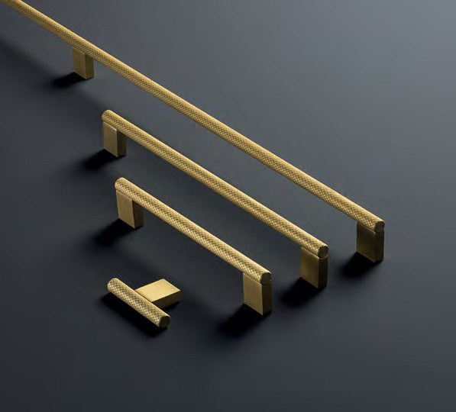
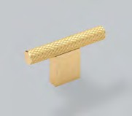
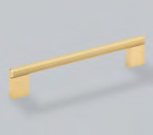
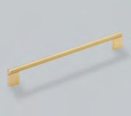
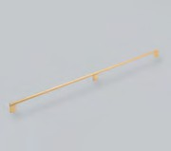
108 109

1 6 0 MM D HANDLE

C ODE : GMID 1 6 0
FINISH CODE
BN, BSB, CP, MBC, MBL
Milano

HOLE CENTRES
160MM
PROJECTION
28MM
OVERALL LENGTH
169MM
WIDTH X HEIGHT
9MM X 9MM

3 2 0 MM D HANDLE

C ODE : GMID 3 2 0
FINISH CODE
BN, BSB, CP, MBL

HOLE CENTRES
320MM
PROJECTION
28MM
OVERALL LENGTH
329MM
WIDTH X HEIGHT
9MM X 9MM

Milano Collection

Perfect simplicity, 90 degree angles in a range of modern finishes.
Made from Zamac. Includes fixings.
A modernist classic, the Milano is a simple and sophisticated way
to lift any room.

FINISHES

BRUSHED NICKEL (BN)
BRUSHED SATIN BRASS (BSB)
CHROME
PLATED (CP)
MATT BRUSHED COPPER (MBC)
MATT BLACK
(MBL)

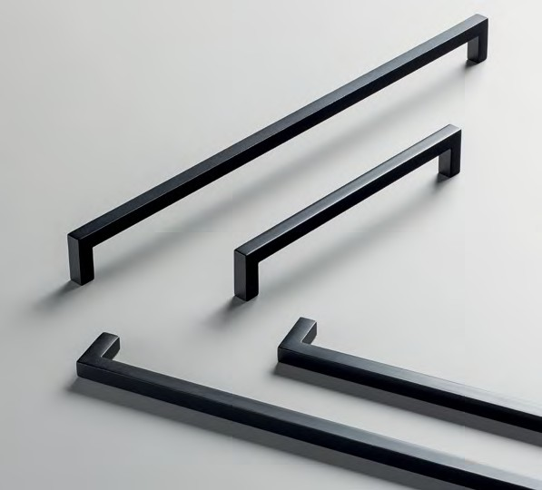
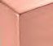
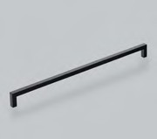
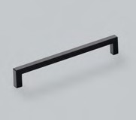
110 111

yn

Aubyn Collection

This striking collection combines a beautifully faceted knob with clean concave lines on the bar handle to deliver the perfect finishing touch to your application.
Finishes of Bronze, Brushed Satin Brass and Polished Nickel are available.
Made from Zamac. Includes fixings.

FINISHES

BRONZE
(BRO)
BRUSHED SATIN BRASS (BSB)
POLISHED NICKEL (PN)

3 5 MM KNOB

C ODE : G A U K 03 5
FINISH CODE
BRO, BSB, PN

PROJECTION
25MM
KNOB DIAMETER
35MM

1 6 0 MM PULL HANDLE

C ODE : G A U P 160
FINISH CODE
BRO, BSB, PN

HOLE CENTRES
160MM
PROJECTION
39MM
OVERALL LENGTH
218MM
BAR THICKNESS
18MM X 18MM

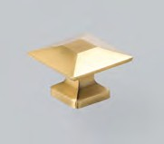
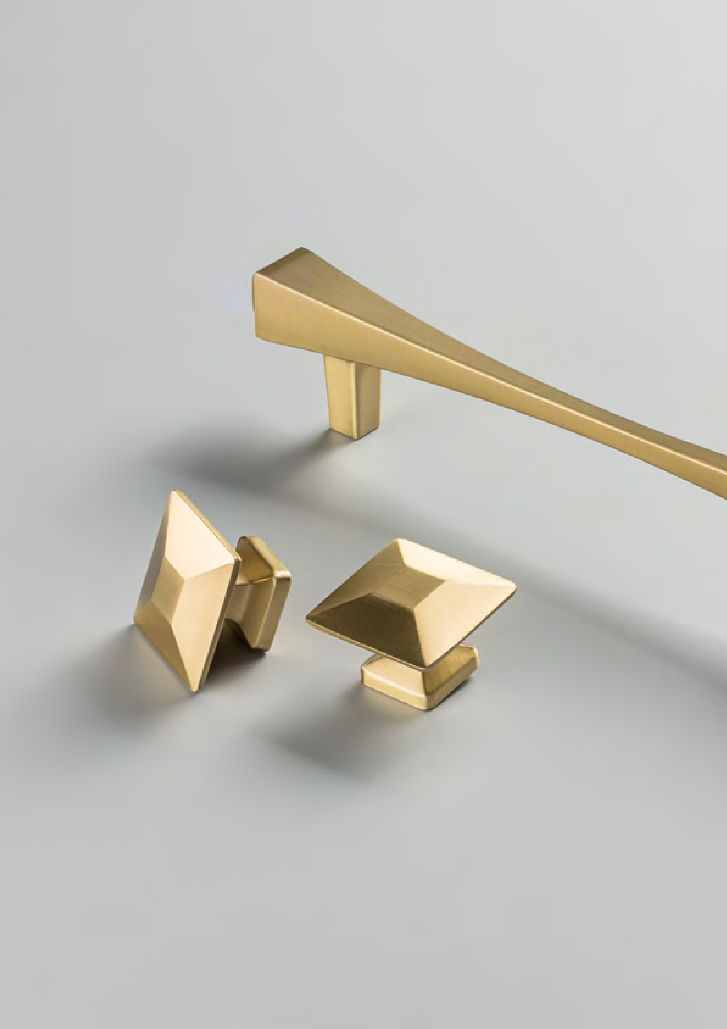
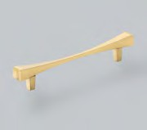
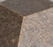
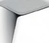
112 113

1 6 0 MM D HANDLE

C ODE : G C A D 160
FINISH CODE
CP, MBL, SB
Campana

HOLE CENTRES
160MM
PROJECTION
28MM
OVERALL LENGTH
178MM
BAR THICKNESS
8.5MM X 7MM

1 9 2 MM D HANDLE

C ODE : G C A D 192
FINISH CODE
CP, MBL, SB

HOLE CENTRES
192MM
PROJECTION
28MM
OVERALL LENGTH
210MM
BAR THICKNESS
8.5MM X 7MM

3 2 0 MM D HANDLE

C ODE : G C A D 320
FINISH CODE
CP, MBL, SB

Campana Collection

HOLE CENTRES PROJECTION OVERALL LENGTH BAR THICKNESS

320MM
28MM
338MM
8.5MM X 7MM

An attractive suite of three pull handles with design detail on the inside and outside of the handle ends. Angular and exciting.
Made from Zamac. Includes fixings.

FINISHES

CHROME
PLATED (CP)
MATT BLACK
(MBL)
SATIN BRASS
(SB)

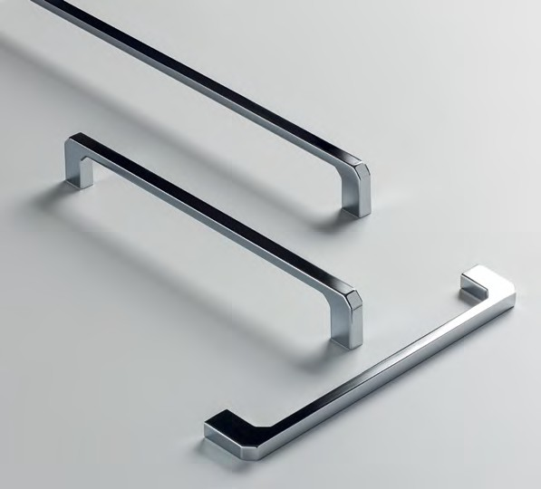
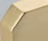
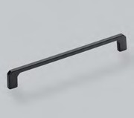
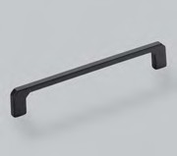
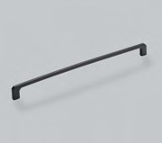
114 115

3 2 MM PULL HANDLE

C ODE : GL AP 0 3 2
FINISH CODE
CP, MBL, SB
Kellas

HOLE CENTRES
32MM
PROJECTION
28MM
OVERALL LENGTH
65MM
HEIGHT
56MM

The Lago collection is a coming together of style and purpose.

Lago Collection

With its distinctive form and functionally centric design, Lago promises to make a statement.
Made from Zamac. Includes fixings.
Clean effortless lines that will
compliment and not dominate a modern space and aesthetic.

FINISHES

CHROME
PLATED (CP)
MATT BLACK
(MBL)
SATIN BRASS
(SB)

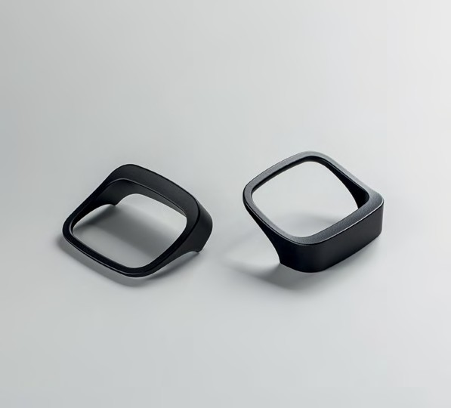
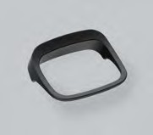
116 117

9 6 MM B AR HANDLE

C ODE : GC OB 0 9 6
FINISH CODE
AC, BN, BSB, MBL
Coleby

HOLE CENTRES
96MM
PROJECTION
32MM
OVERALL LENGTH
136MM
BAR THICKNESS
12MM

1 2 8 MM B AR HANDLE

C ODE : G C O B 128
FINISH CODE
AC, BN, BSB, MBL

HOLE CENTRES
128MM
PROJECTION
32MM
OVERALL LENGTH
168MM
BAR THICKNESS
12MM

1 6 0 MM B AR HANDLE

C ODE : G C O B 160
FINISH CODE
AC, BN, BSB, MBL

Coleby Collection

HOLE CENTRES
160MM

PROJECTION
32MM

OVERALL LENGTH
230MM

BAR THICKNESS
12MM

Bold circular design and clean lines are a trademark of this collection.
Three finish additions give a modern touch to the classic form.
Made from Steel. Includes fixings.

FINISHES

2 5 6 MM B AR HANDLE

C ODE : G C O B 256
FINISH CODE
AC, BN, BSB, MBL

ANTIQUE COPPER (AC)

BRUSHED NICKEL (BN)

BRUSHED SATIN BRASS (BSB)

MATT BLACK
(MBL)
HOLE CENTRES
256MM
PROJECTION
32MM
OVERALL LENGTH
326MM
BAR THICKNESS
12MM

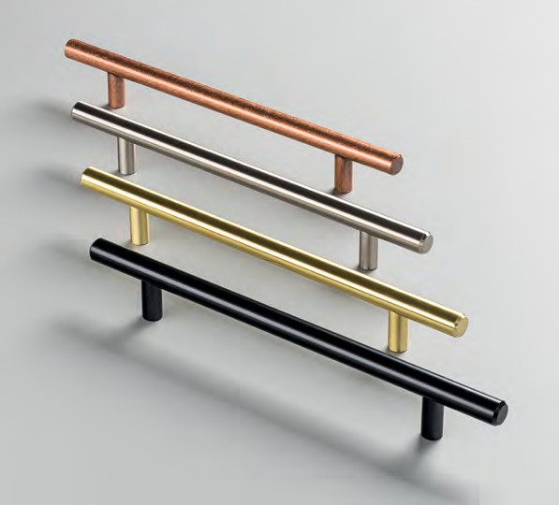
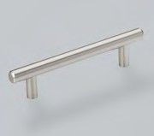
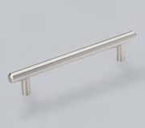
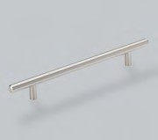
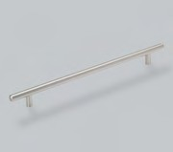
118 119

Hugo Ilsa

Hugo Collection Ilsa Collection

The Hugo collection is a timeless range that will add that special touch to your room. Simple, sophisticated and refined.
Made from Aluminium. Fixings sold separately.
This Ilsa design features confident lines that will add that final flourish to your room.
Made from Zamac. Includes fixings.

FINISHES FINISHES

POLISHED NICKEL (PN)
BRUSHED SATIN BRASS (BSB)
POLISHED NICKEL (PN)

3 8 MM KNOB

C ODE : GHUK 0 3 8 PN
FINISH CODE
PN

3 8 MM KNOB

C ODE : GILK 0 3 8
FINISH CODE
BSB, PN

PROJECTION
36MM
KNOB DIAMETER
38MM
PROJECTION
45MM
KNOB DIAMETER
38MM

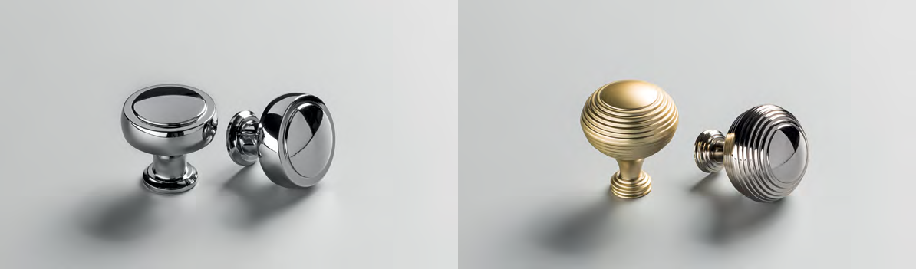
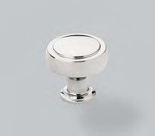
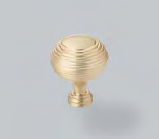
120 121

Chelsea Ivo

Chelsea Collection

The Chelsea collection is a simple and confident design that will compliment your chosen aesthetic.
Made from Brass. Includes fixings.

Ivo Collection

When all you need is that grand, statement piece – bold, but elegant. Add the perfect finishing touch with Ivo.
Made from Aluminium. Includes fixings.

FINISHES FINISHES

BRUSHED SATIN BRASS (BSB)
POLISHED NICKEL (PN)
BRONZE
(BRO)
BRUSHED SATIN BRASS (BSB)
POLISHED NICKEL (PN)

3 8 MM KNOB

C ODE : GCHK 0 3 8
FINISH CODE
BSB, PN

4 5 MM KNOB

C ODE : GIVK 04 5
FINISH CODE
BRO, BSB, PN

PROJECTION
31MM
KNOB DIAMETER
38MM
PROJECTION
32MM
KNOB DIAMETER
45MM

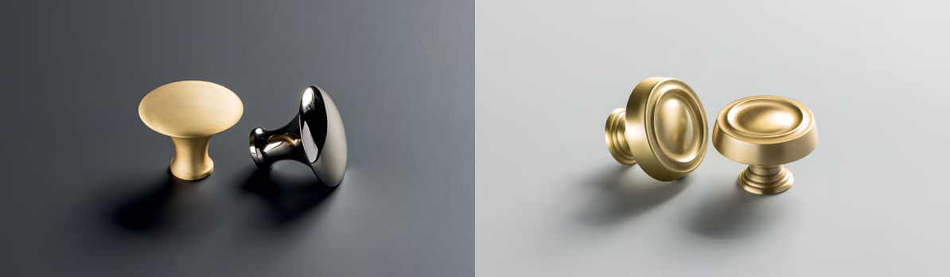
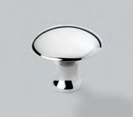
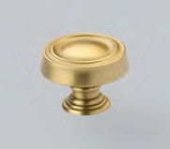
122 123

Evora Kew

Evora Collection Kew Collection

Refined and discreet, the Evora collection will add a touch of sophistication to a contemporary home.
Made from Zamac. Includes fixings.
Classic with a contemporary finish, the Kew will give a modern look and feel to any piece.
Made from Brass. Includes fixings.

FINISHES FINISHES

BRUSHED NICKEL (BN)
CHROME
PLATED (CP)
SATIN BRASS
(SB)
MATT BLACK
(MBL)
BRUSHED SATIN BRASS (BSB)
POLISHED NICKEL (PN)

2 4 MM KNOB

C ODE : G E V K 0 2 4
FINISH CODE
BN, CP, SB, MBL

3 8 MM KNOB

C ODE : GKEK 0 3 8
FINISH CODE
BSB, PN

PROJECTION
29MM
KNOB DIAMETER
24MM
PROJECTION
31MM
KNOB DIAMETER
38MM

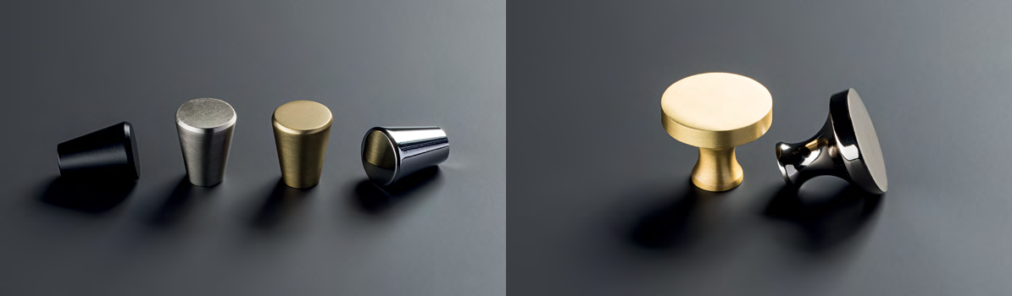
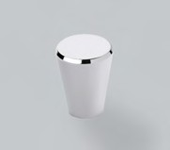
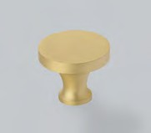
124 125

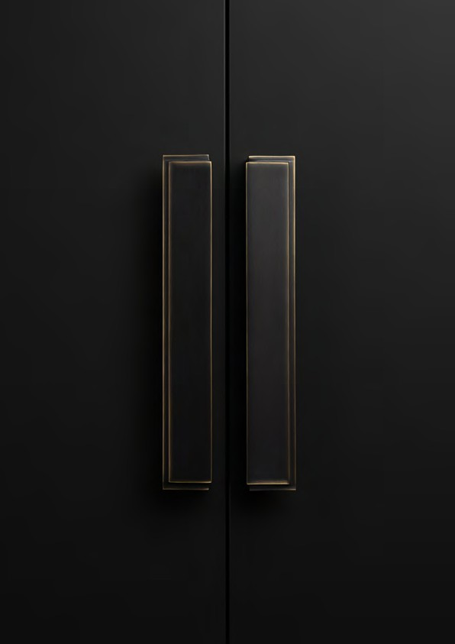
Felix

Discover handles worth talking about at:

@hendelandhendel

